# Payroll tax

## Overview

The payroll tax assessment covers revenue from taxes levied on remuneration paid or payable by an employer to its employees when the total taxable remuneration of an employer (or group of employers) exceeds a threshold amount. It includes payroll tax surcharges applied by some states and territories (states) such as mental health levies.

The assessment recognises a state’s capacity to raise payroll tax revenue is influenced by the total remuneration paid by employers in the private sector and the   
non-general government public sector, where those employers’ total Australian remuneration exceeds an average tax-free threshold. States with above average remuneration above the average threshold will have greater revenue raising capacity.

## Actual state revenue

The first step in calculating assessed revenue is identifying state revenue.[1] Payroll tax accounted for 18.8% of total own-source revenue in 2022–23 (Table 1).[2]

Table 1 Payroll tax revenue by state, 2022–23

|  |  |  |  |  |  |  |  |  |  |
| --- | --- | --- | --- | --- | --- | --- | --- | --- | --- |
|  | NSW | Vic | Qld | WA | SA | Tas | ACT | NT | Total |
| Payroll Tax ($m) | 11,594 | 8,421 | 5,850 | 5,007 | 1,693 | 494 | 733 | 273 | 34,066 |
| Payroll Tax ($pc) | 1,406 | 1,254 | 1,086 | 1,766 | 922 | 863 | 1,589 | 1,087 | 1,295 |
| Proportion of total own-source revenue (%) | 22.2 | 21.1 | 12.7 | 18.1 | 20.7 | 21.4 | 20.8 | 16.0 | 18.8 |

## Structure of assessment

Table 2 shows the driver that influences each state’s revenue capacity.

Table 2 Structure of the payroll tax assessment

|  |  |  |
| --- | --- | --- |
| Component | Driver | Influence measured by driver |
| Payroll tax | Value of taxable remuneration | States with greater private sector and non-general government public sector remuneration above an average threshold have greater revenue raising capacity. |

## Data

The data used in the assessment are outlined in Table 3.

Table 3 Data used in the payroll tax assessment

|  |  |  |
| --- | --- | --- |
| Source | Data | Updated |
| ABS | Compensation of employees – private and public sectors, National Accounts | Annually |
| Total Public sector employment and earnings | Annually |
| Public sector employment and earnings, selected industries and higher education institutions (customised data) | Annually |
| Private sector wages and salaries data, Quarterly Business Indicators Survey (customised data) | Annually |

Note: The adjusted budget data sources are outlined in the adjusted budget chapter of the *Commission’s Assessment Methodology*.

Data for 2021-22 from the Commonwealth departments of Defence, and Foreign Affairs and Trade were used to remove remuneration of Australian Defence Force and embassy personnel. Data for 2021-22 from the Commonwealth Department of Education were used to split remuneration of higher education employees in Tasmania, the ACT and the Northern Territory. Changes to ABS data mean these adjustments are unnecessary from the 2022–23 assessment year.

## Assessment method

A state’s assessed capacity to raise payroll tax revenue is calculated by applying the Australian average payroll tax rate to the total taxable remuneration in that state.

The assessment uses ABS National Accounts data on compensation of employees since it broadly aligns with the forms of remuneration liable for payroll tax (including wages and salaries, superannuation, allowances and fringe benefits). However, ABS compensation of employees data are unable to be dissected by size of payroll. Therefore, ABS wages and salaries data are used to split private and public sector compensation of employees above and below an average tax-free threshold. ABS wages and salaries are also used to remove remuneration paid by the general government sector in each state.

There are 4 main steps in calculating assessed payroll tax revenue:

* determining the average tax-free threshold
* determining the assessed revenue base
* determining the average tax rate
* applying the average tax rate to each state’s assessed revenue base.

The average tax-free threshold is a weighted average of individual states’ thresholds, with weights based on each state’s share of total compensation of employees. Table 4 shows this calculation for the 2022–23 assessment year. The weighted threshold is scaled so that it can be applied to wages and salaries in the private and public sectors. The scaling proportion is based on ABS data for 2017–18 to 2022–23 and will remain fixed until the next review. The scaled thresholds are rounded to the nearest $10,000 before being provided to the ABS.

Table 4 Calculating weighted threshold, 2022–23

|  |  |  |  |
| --- | --- | --- | --- |
|  | State shares of total CoE (public & private) | State thresholds | Weighted threshold |
|  |  | $ | $ |
| New South Wales | 0.323 | 1,200,000 | 387,164 |
| Victoria | 0.245 | 700,000 | 171,753 |
| Queensland | 0.193 | 1,300,000 | 250,510 |
| Western Australia | 0.124 | 1,000,000 | 123,983 |
| South Australia | 0.059 | 1,500,000 | 88,696 |
| Tasmania | 0.017 | 1,250,000 | 21,731 |
| Australian Capital Territory | 0.028 | 2,000,000 | 55,406 |
| Northern Territory | 0.011 | 1,500,000 | 16,649 |
| Total weighted average threshold |  |  | 1,115,893 |
| Threshold scaled to wages and salaries portion of total CoE in the private sector (90%) | | | 1,004,304 |
| Threshold scaled to wages and salaries portion of total CoE in the public sector (85%) | | | 948,509 |

Note: CoE is Compensation of Employees

Figure 1 illustrates the calculation of the revenue base. For each state, taxable proportions of wages and salaries are applied to compensation of employees in the private and public sectors. The taxable public sector excludes the general government sector at all levels of government.

Figure 2 illustrates the calculation of each state’s assessed revenue. The average payroll tax rate is calculated by dividing the total Australian payroll tax revenue by the total Australian assessed revenue base. The average payroll tax rate is applied to each state’s assessed revenue base to calculate its assessed revenue.

Figure 1 Calculating payroll tax assessed revenue base

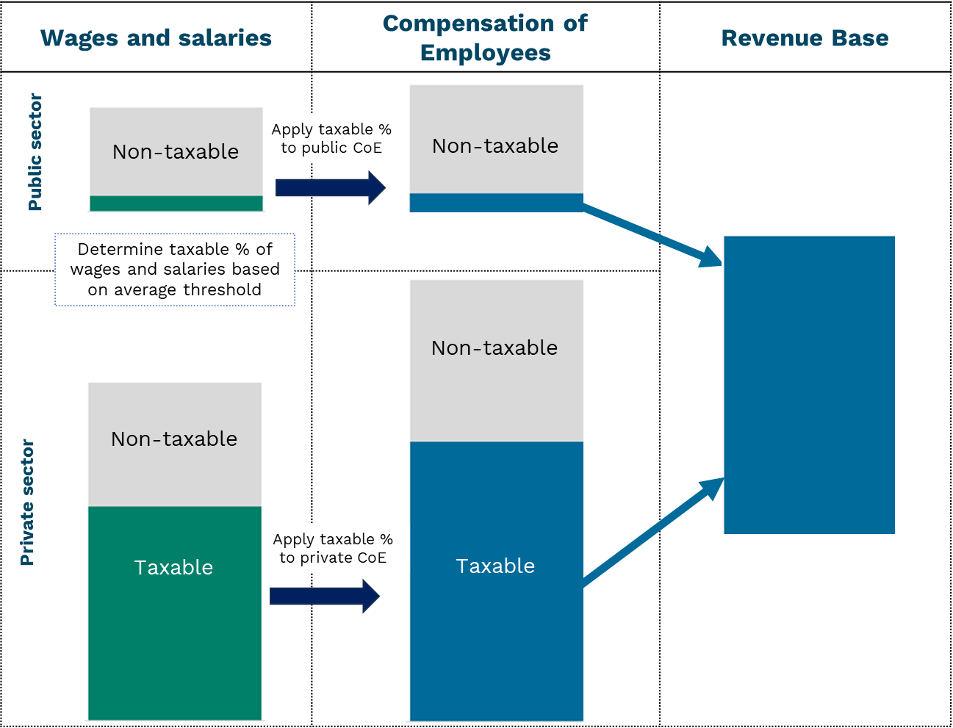

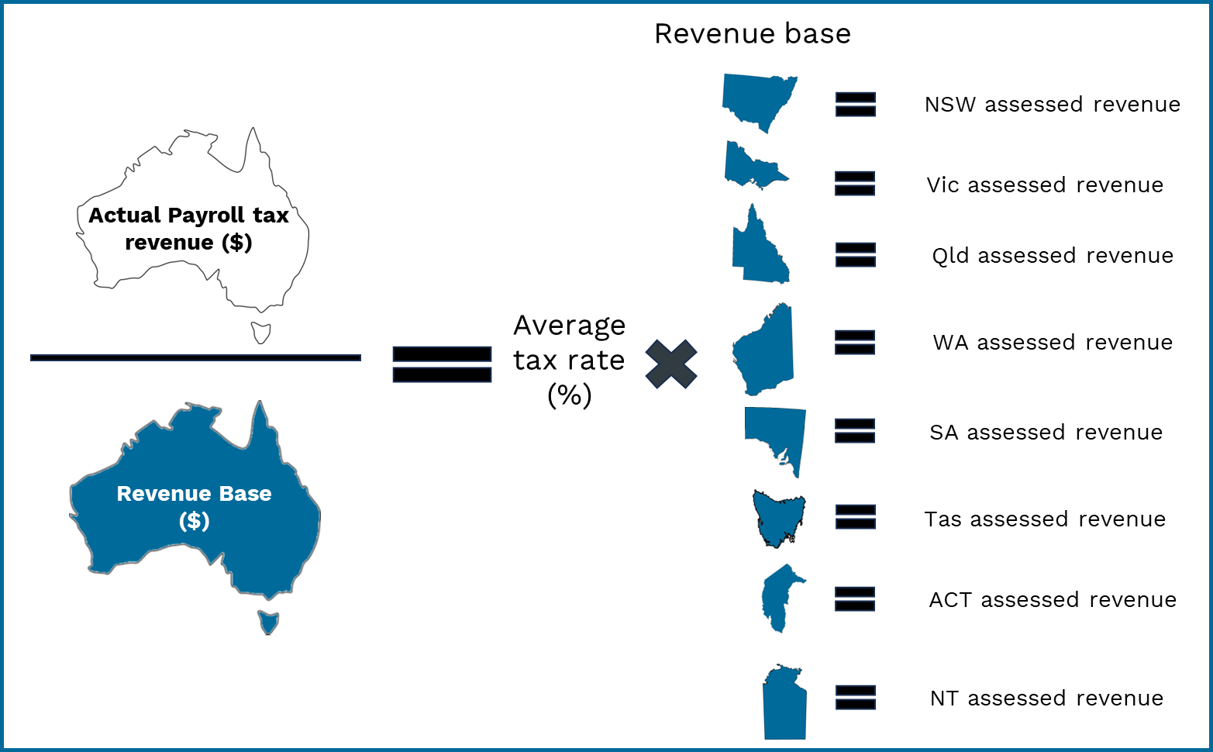Figure 2 Calculating average tax rate and assessed revenue for each state

## GST distribution in the 2025 Review

Table 5 shows the GST impact of the assessment in the 2025 Review.

Table 5 GST impact of the payroll tax assessment, 2025–26

|  |  |  |  |  |  |  |  |  |  |
| --- | --- | --- | --- | --- | --- | --- | --- | --- | --- |
|  | NSW | Vic | Qld | WA | SA | Tas | ACT | NT | Total effect |
|  | $m | $m | $m | $m | $m | $m | $m | $m | $m |
| Payroll Tax | -586 | 178 | 859 | -1,485 | 713 | 274 | 51 | -4 | 2,075 |
| Total ($m) | -586 | 178 | 859 | -1,485 | 713 | 274 | 51 | -4 | 2,075 |
| Total ($pc) | -68 | 25 | 150 | -486 | 375 | 474 | 105 | -15 | 75 |

Note: Magnitude and direction of GST impact can change from year to year.

1. Adjusted budget calculations use ABS Government Finance Statistics data to determine actual state revenue. For further details see the adjusted budget chapter of the *Commission’s Assessment Methodology*.
2. Tables in this chapter, unless otherwise stated, use 2022–23 data.