# Mining revenue

## Overview

The mining revenue assessment covers state and territory (state) revenue from state royalties, non‑royalty revenue associated with mining production and revenue from revenue sharing agreements with the Commonwealth.[1]

The category excludes Commonwealth royalties, including its share of royalties collected under the *Petroleum (Submerged Lands) Act 1967*, the Barrow Island (resource rent royalty) and some onshore oil and gas production in Western Australia from pre‑1979 leases.

The assessment recognises a state’s capacity to raise mining revenue is influenced by the following.

* For most minerals, the total value of mining production — states with a greater share of value of production have greater revenue raising capacity.
* For onshore oil and gas, the total volume of mining production — states with a greater share of volume of production have greater revenue raising capacity.
* For brown coal and grants in lieu of royalties, the revenue raised or received respectively — states with a greater share of revenue raised or received have greater revenue raising capacity.

## Actual state revenue

The first step in calculating assessed revenue is identifying actual state revenue.[2] Mining royalties accounted for 20% of total own-source revenue in 2022–‍23. Table 1 shows actual revenue broken down by component and Table 2 shows actual revenue by state.[3] Royalties are more volatile than other revenues and their share of total own-source revenue can vary significantly year to year. Mining revenue is concentrated in 3 states: New South Wales (13%), Queensland (50%) and Western Australia (34%).

Table 1 Mining revenue by component, 2022–23

|  |  |  |
| --- | --- | --- |
|  | 2022-23 | |
|  | $pc | $m |
| Grants in lieu of royalties | 56 | 1,482 |
| Coal | 758 | 19,944 |
| Gold | 28 | 733 |
| Copper | 13 | 336 |
| Lithium | 40 | 1,043 |
| Nickel | 5 | 138 |
| Other minerals | 136 | 3,571 |
| Iron ore | 346 | 9,095 |
| Total | 1,381 | 36,342 |
| Proportion of total own-source revenue (%) |  | 20.0 |

1. For confidentiality reasons, the Commission does not publish data on its bauxite and onshore oil and gas assessments. This assessment is an aggregation of the bauxite, onshore oil and gas and other minerals assessments.

Table 2 Mining revenue by state, 2022–23

|  |  |  |  |  |  |  |  |  |  |
| --- | --- | --- | --- | --- | --- | --- | --- | --- | --- |
|  | NSW | Vic | Qld | WA | SA | Tas | ACT | NT | Total |
| Mining revenue ($m) | 4,658 | 129 | 18,214 | 12,468 | 379 | 62 | 0 | 432 | 36,342 |
| Mining revenue ($pc) | 565 | 19 | 3,381 | 4,398 | 207 | 108 | 0 | 1,720 | 1,381 |
| Proportion of total own-source revenue (%) | 8.9 | 0.3 | 39.6 | 45.2 | 4.6 | 2.7 | 0.0 | 25.3 | 20.0 |

## Structure of assessment

Table 3 shows the drivers that influence each state’s revenue raising capacity.

Table 3 Structure of the mining revenue assessment

|  |  |  |
| --- | --- | --- |
| Component | Driver | Influence measured by driver |
| Iron ore | Value of production | States with a greater total value of production have greater revenue raising capacity. |
|  | Actual per capita (revenue raised) | The revenue raising capacity of states with brown coal is equal to the royalties raised. |
| Coal | Value of production | States with a greater total value of production have greater revenue raising capacity. |
|  | Value distribution adjustment | States with a greater proportion of high value coal have greater revenue raising capacity. |
| Bauxite | Value of production | States with a greater total value of production have greater revenue raising capacity. |
| Onshore oil and gas | Volume of production | States with a greater total volume of production have greater revenue raising capacity. |
| Gold | Value of production | States with a greater total value of production have greater revenue raising capacity. |
| Copper | Value of production | States with a greater total value of production have greater revenue raising capacity. |
| Lithium | Value of production | States with a greater total value of production have greater revenue raising capacity. |
| Nickel | Value of production | States with a greater total value of production have greater revenue raising capacity. |
| Other minerals | Value of production | States with a greater total value of production have greater revenue raising capacity. |
| Grants in lieu of royalties | Actual per capita (revenue received) | The revenue raising capacity of states is equal to the revenue they receive. |

Note: The coal assessment calculates a revenue capacity using a state’s share of the total value of production in each of 2 price bands (above and below $200 per tonne). The value distribution adjustment captures the difference between an assessment using 2 price bands and an aggregate coal assessment.

## Data

The data used in the assessment are outlined in Table 4.

Table 4 Data used in the mining revenue assessment

|  |  |  |
| --- | --- | --- |
| Source | Data | Updated |
| Commonwealth of Australia | Revenue from revenue sharing agreements with the Commonwealth published in Final Budget Outcome | Annually |
| State departments | Royalty revenue by mineral | Annually |
| Value of production by mineral | Annually |
| Volume of production for onshore oil and gas | Annually |

Note: The adjusted budget data sources are outlined in the adjusted budget chapter of the *Commission’s Assessment Methodology*.

### Revenue data

The Commission obtains revenue data from multiple sources. The category comprises royalty revenue sourced from ABS Government Finance Statistics (GFS) and revenue from revenue sharing agreements with the Commonwealth sourced from the Commonwealth’s Final Budget Outcome.

States provide revenue by mineral. These data are used for most mineral components. Figure 1 shows the revenue for the other minerals component is derived as the difference between a state’s GFS royalty revenue and its total state revenue (excluding other minerals royalties).

Figure 1 Derivation of royalty revenue for the other minerals component

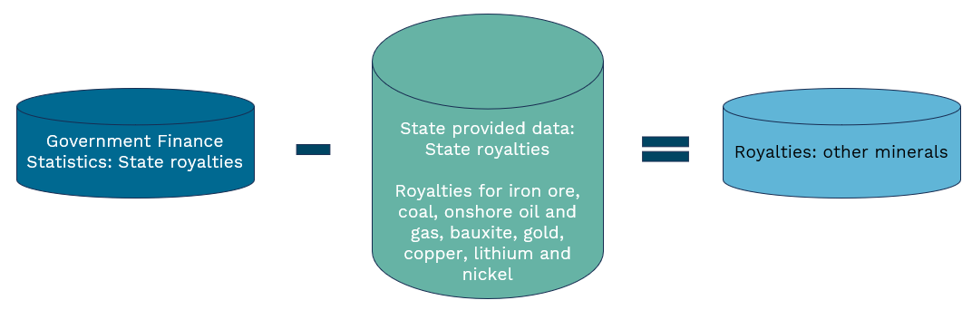

### Assessment data

The Commission sources value and volume of production by mineral from states. For coal, states provide revenue and value of production data for 2 price bands (above and below $200 per tonne).

Queensland and the Northern Territory provide aggregated data because confidentiality restrictions prevent them from providing data for each mineral component. The Commission splits their aggregated data using processes agreed with each state.

Western Australia is the only state to provide value of production data for both alumina and bauxite. The Commission converts its alumina value of production to a bauxite equivalent using a process agreed with the state.

## Assessment method

States impose different royalty rates on different minerals. As a consequence, the assessment uses a mineral‑by‑mineral approach to assess capacity. Under this approach, separate assessments are made for individual minerals where it is material to do so. The remaining minerals are combined and assessed together. Revenue from revenue sharing agreements with the Commonwealth are assessed using the revenue received by the relevant states.

### Revenue base

The assessment has 10 components. For each component, a state’s capacity to raise mining revenue is calculated using its share of one of the following:

* total value of production
* total volume of production or
* revenue raised or received.

For most components, the revenue base is the value of minerals produced. For the onshore oil and gas component, it is the volume of production. For the grants in lieu of royalties component, it is the revenue received. For coal, there is a different approach which is discussed in the section below.

For each component, an average royalty rate is derived by dividing total revenue by the total revenue base. Figure 2 shows assessed revenue is derived by applying the average royalty rate to a state’s revenue base.

Figure 2 Calculating assessed revenue

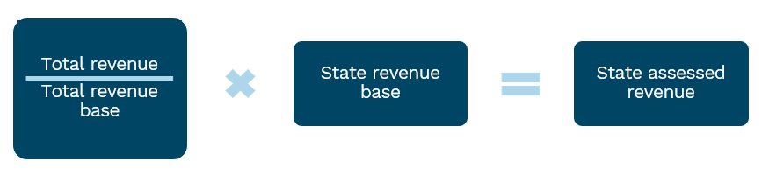

#### The coal assessment

The calculation of assessed revenue for coal is different. Some states have higher revenue capacity because a higher proportion of their coal production comprises high‑value metallurgical coal, which attracts a higher price. Their revenue capacity is further increased when progressive royalty rates are imposed. To capture states’ increased capacity, the coal assessment calculates a state’s revenue capacity using its share of the total value of production in each of 2 price bands (above and below $200 per tonne).

A value distribution adjustment is derived by calculating:

* each state’s assessed coal revenue for each price band and combining them
* each state’s assessed coal revenue using an aggregate coal assessment
* the ratio of the 2 outcomes.

A state’s coal revenue base is its value of coal production multiplied by its value distribution adjustment.

The exception is Victoria. Its coal does not have a market price as it is largely an internal transfer within mining/electricity generation entities. In the absence of a price, there is no reliable way to derive a measure of its value of coal production. Consequently, the Commission estimates its coal capacity as the revenue raised.

This is not a separate coal assessment. It is a way to estimate coal capacity for a state producing coal that has no price. Victoria’s estimated capacity is included with the capacities of other states in the coal assessment.

#### Confidential data

A state may provide the Commission with the value of production for a particular mineral on the condition the Commission does not publish its data. In these circumstances, the Commission uses the state’s data to derive an assessment for the mineral. To maintain the confidentiality of the relevant state data, the Commission combines that assessment with the assessment for another mineral component.

States provided confidential bauxite and onshore oil and gas production data. The Commission maintains the confidentiality of these data by:

* calculating assessed revenue for each mineral
* combining the assessed revenues for both minerals with the assessed revenue for the other minerals component
* setting the revenue base for the other minerals component to each state’s share of the aggregate assessed revenues for all three minerals (see Figure 3).

Figure 3 Maintaining confidentiality of state data

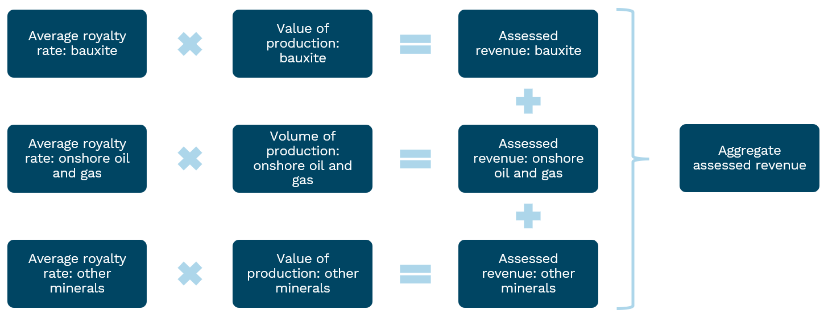

#### Category assessed revenue

Category assessed revenue is derived by summing the assessed revenue for each component.

## GST distribution in the 2025 Review

Table 5 shows the GST impact of the assessment in the 2025 Review.

Table 5 GST impact of the mining revenue assessment, 2025–26

|  |  |  |  |  |  |  |  |  |  |
| --- | --- | --- | --- | --- | --- | --- | --- | --- | --- |
|  | NSW | Vic | Qld | WA | SA | Tas | ACT | NT | Total effect |
|  | $m | $m | $m | $m | $m | $m | $m | $m | $m |
| Grants in lieu of royalties | 410 | 339 | 271 | -1,171 | 90 | 27 | 23 | 11 | 1,171 |
| Coal | -1,259 | 4,384 | -7,009 | 1,873 | 1,190 | 358 | 302 | 161 | 8,268 |
| Gold | 182 | 185 | 138 | -546 | 29 | 16 | 15 | -20 | 565 |
| Copper | 37 | 107 | -15 | -19 | -126 | 5 | 7 | 4 | 160 |
| Lithium | 230 | 190 | 152 | -656 | 50 | 15 | 13 | 5 | 656 |
| Nickel | 45 | 37 | 29 | -126 | 10 | 2 | 2 | 1 | 126 |
| Other minerals | 1,044 | 826 | -1,674 | -7 | -27 | -18 | 62 | -206 | 1,932 |
| Iron ore | 3,696 | 3,057 | 2,444 | -10,424 | 716 | 196 | 206 | 110 | 10,424 |
| Total ($m) | 4,385 | 9,125 | -5,664 | -11,075 | 1,931 | 601 | 630 | 66 | 16,739 |
| Total ($pc) | 506 | 1,273 | -989 | -3,625 | 1,015 | 1,041 | 1,305 | 258 | 601 |

Note: Magnitude and direction of GST impact can change from year to year.

1. For confidentiality reasons, the Commission does not publish data on its bauxite and onshore oil and gas assessments. This assessment is an aggregation of the bauxite, onshore oil and gas and other minerals assessments.
2. Onshore oil and gas revenues are assessed using the volume of mineral production, the remaining revenues in this component are assessed using the value of mineral production.

1. The Commonwealth collects royalties under the *Offshore Petroleum (Royalty) Act 2006* in respect of the North West Shelf oil and gas project. It shares these royalties with Western Australia. It also provides revenue to Western Australia to compensate it for the loss of royalty revenue resulting from the removal of the exemption of condensate from crude oil excise.
2. Adjusted budget calculations use ABS Government Financial Statistics data to determine actual state revenue. For further details see the adjusted budget chapter of the *Commission’s Assessment Methodology*.
3. Tables used in this chapter, unless state otherwise, use 2022–‍23 data.