# Commonwealth payments

## Overview

The Commonwealth payments assessment covers payments for specific purposes made by the Commonwealth to the states and territories (states). Payments for specific purposes are an important source of revenue available to states to provide services and invest in infrastructure. States that receive a higher share of these payments are fiscally advantaged compared to states that receive a lower share. Therefore, payments for specific purposes are taken into account when determining each state’s relative fiscal capacity and GST requirement.

The scope of the Commonwealth payments assessment is limited to payments for specific purposes listed in the Australia’s Federal Financial Relations part of the Commonwealth’s Final Budget Outcome.

Not all of these payments affect the GST distribution. The Commission applies a principles-based framework to determine which Commonwealth payments impact the GST distribution. This ensures consistent and transparent outcomes. The following guideline is used to decide the treatment of payments on a case-by-case basis:

payments which support state services, and for which expenditure needs are assessed, will impact the GST relativities.

Payments may also be excluded due to a terms of reference instruction from the Commonwealth Treasurer, known as ‘quarantining’. The Commission has no role in a decision to quarantine a payment.

Figure 1 sets out the Commission’s framework for the treatment of Commonwealth payments and whether a payment should impact the GST distribution.

Figure 1 Decision framework for the treatment of Commonwealth payments

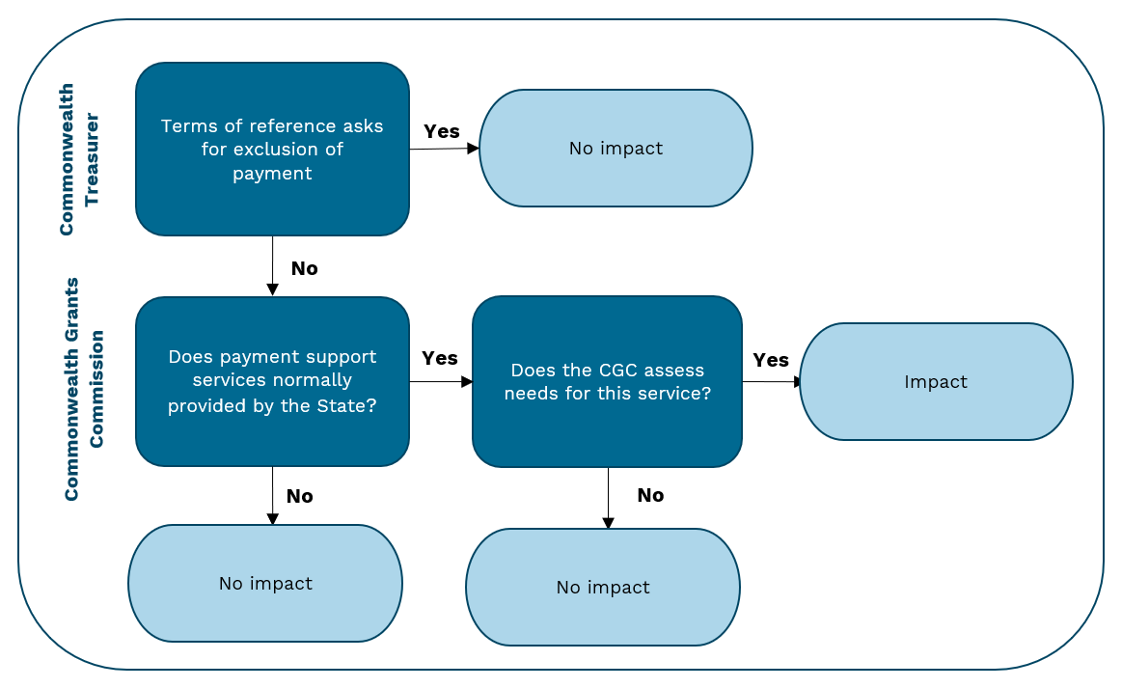

## Commonwealth payments to states

The total value of all Commonwealth payments to states in 2022–23 is shown in Table 1 and the per capita value of these payments is shown in Table 2.[1]

Approximately one-third of all payments from the Commonwealth to states affect the GST distribution (Impact payments), as shown in Table 3.

Table 1 Payments from the Commonwealth by state, 2022–23

|  |  |  |  |  |  |  |  |  |  |
| --- | --- | --- | --- | --- | --- | --- | --- | --- | --- |
|  | NSW | Vic | Qld | WA | SA | Tas | ACT | NT | Total |
|  | $m | $m | $m | $m | $m | $m | $m | $m | $m |
| No impact payments | 3,307 | 3,085 | 2,896 | 1,746 | 984 | 482 | 260 | 517 | 13,276 |
| Terms of Reference | 1,046 | 1,058 | 748 | 454 | 262 | 123 | 68 | 299 | 4,058 |
| Commission decision | 2,261 | 2,027 | 2,148 | 1,292 | 722 | 359 | 192 | 218 | 9,218 |
| Impact payments | 15,303 | 11,521 | 11,041 | 5,718 | 3,339 | 1,286 | 729 | 962 | 49,898 |
| Payments assessed EPC | 1,688 | 2,697 | 886 | -35 | 454 | 52 | 169 | 25 | 5,936 |
| Commonwealth payments treated as own-source revenue | 0 | 0 | 0 | 1,474 | 0 | 0 | 0 | 0 | 1,474 |
| GST | 24,453 | 17,972 | 17,358 | 6,174 | 7,354 | 3,308 | 1,572 | 3,803 | 81,994 |
| Total payments from the Commonwealth | 44,750 | 35,275 | 32,181 | 15,077 | 12,130 | 5,128 | 2,730 | 5,307 | 152,577 |

Note: Negative amounts for payments assessed EPC occurs when the total of all Commonwealth payments reported in the Final Budget Outcome is greater than the value reported in Government Finance Statistics, excluding out of scope payments.

Table 2 Payments from the Commonwealth per capita by state, 2022-23

|  |  |  |  |  |  |  |  |  |  |
| --- | --- | --- | --- | --- | --- | --- | --- | --- | --- |
|  | NSW | Vic | Qld | WA | SA | Tas | ACT | NT | Total |
|  | $pc | $pc | $pc | $pc | $pc | $pc | $pc | $pc | $pc |
| No impact payments | 401 | 459 | 538 | 616 | 536 | 841 | 564 | 2,056 | 505 |
| Terms of Reference | 127 | 158 | 139 | 160 | 143 | 215 | 148 | 1,190 | 154 |
| Commission decision | 274 | 302 | 399 | 456 | 393 | 627 | 416 | 867 | 350 |
| Impact payments | 1,855 | 1,715 | 2,050 | 2,017 | 1,818 | 2,246 | 1,580 | 3,829 | 1,897 |
| Payments assessed EPC | 205 | 402 | 164 | -12 | 247 | 90 | 367 | 99 | 226 |
| Commonwealth payments treated as own-source revenue | 0 | 0 | 0 | 520 | 0 | 0 | 0 | 0 | 56 |
| GST | 2,965 | 2,675 | 3,223 | 2,178 | 4,005 | 5,776 | 3,408 | 15,133 | 3,117 |
| Total payments from the Commonwealth | 5,425 | 5,251 | 5,974 | 5,318 | 6,607 | 8,954 | 5,919 | 21,117 | 5,800 |

Table 3 Proportion of payments from the Commonwealth by state, 2022-23

|  |  |  |  |  |  |  |  |  |  |
| --- | --- | --- | --- | --- | --- | --- | --- | --- | --- |
|  | NSW | Vic | Qld | WA | SA | Tas | ACT | NT | Total |
|  | % | % | % | % | % | % | % | % | % |
| No impact payments | 7.4 | 8.7 | 9.0 | 11.6 | 8.1 | 9.4 | 9.5 | 9.7 | 8.7 |
| Terms of Reference | 2.3 | 3.0 | 2.3 | 3.0 | 2.2 | 2.4 | 2.5 | 5.6 | 2.7 |
| Commission decision | 5.1 | 5.7 | 6.7 | 8.6 | 6.0 | 7.0 | 7.0 | 4.1 | 6.0 |
| Impact payments | 34.2 | 32.7 | 34.3 | 37.9 | 27.5 | 25.1 | 26.7 | 18.1 | 32.7 |
| Payments assessed EPC | 3.8 | 7.6 | 2.8 | -0.2 | 3.7 | 1.0 | 6.2 | 0.5 | 3.9 |
| Commonwealth payments treated as own-source revenue | 0.0 | 0.0 | 0.0 | 9.8 | 0.0 | 0.0 | 0.0 | 0.0 | 1.0 |
| GST | 54.6 | 50.9 | 53.9 | 41.0 | 60.6 | 64.5 | 57.6 | 71.7 | 53.7 |
| Total payments from the Commonwealth | 100.0 | 100.0 | 100.0 | 100.0 | 100.0 | 100.0 | 100.0 | 100.0 | 100.0 |

## Structure of assessment

Table 4 shows the structure of the assessment.

Table 4 Structure of the Commonwealth payments assessment

|  |  |  |
| --- | --- | --- |
| Component | Driver | Influence measured by driver |
| Payments affecting state fiscal capacities | Actual per capita | States which receive above-average per capita Commonwealth payments have greater fiscal capacity. |
| Other Commonwealth payments | Equal per capita | These payments are not differentially assessed. |

Note: The Commonwealth payments category does not include GST payments or no impact payments. No impact payments are removed from the revenue and expenditure included in the adjusted budget (see Figure 2).

## Data

The data used in the assessment are outlined in Table 5.

Table 5 Data used in the Commonwealth payments assessment

|  |  |  |
| --- | --- | --- |
| Source | Data | Updated |
| Commonwealth of Australia | Final Budget Outcome | Annually |
| Department of Infrastructure, Transport, Regional Development, Communications and the Arts | Details of road and rail payments | Annually |
| Details of city and regional deals payments | Annually |
| Department of Health and Aged Care | Cross-border adjustment | Annually |
| COVID-19 Health adjustment | Annually for life of payment |

Note: Final Budget Outcome data also include additional tables related to ‘through payments’, reward payments, memorandum items, Financial Assistance Grants to local governments and Mid-Year Economic and Fiscal Outlook population and GST revenue figures.

## Assessment method

The Commission applies the following guideline to decide the treatment of payments on a case-by-case basis.

Payments which support state services, and for which expenditure needs are assessed, will impact the GST relativities.

The first consideration is whether the payment supports state services. If the payment supports states services, the second consideration is whether the Commission assesses expenditure needs for those services. Where the purpose of the payment broadly aligns with the assessment of expenditure needs, the Commission would consider ‘needs are assessed’ for the payment.

For most payments, making decisions on their treatment using the guideline is straightforward. For a minority of payments, making decisions can be more difficult and the Commission is required to use its judgement. This mainly arises due to difficulties in determining whether a particular payment supports a state service or relates to a Commonwealth function; or difficulties in deciding what the payment is for, and in that context, whether the Commission assesses expense needs.

Where there is substantial uncertainty about the payment’s purpose or whether relative state expenditure needs are assessed, the Commission will default to an ‘impact’ treatment and include it in the GST calculation. States have an opportunity during the annual consultation process to provide evidence in support of a ‘no impact’ treatment.

In some cases, the Commission may decide a payment is for multiple purposes or serves both a state and non-state function. While the Commission’s preference is to allocate based on the main purpose of the payment, in some cases the Commission will choose to split a payment. A payment may be split on a fixed proportion or using additional data provided by the Commonwealth departments shown in Table 5.

Impact and no impact treatments are implemented as follows.

* Payments affecting relativities (impact payments)

the revenue is assessed actual per capita in the Commonwealth payments category

the related expenditure is assessed using the same drivers as other expenditure in the relevant category.

* Payments not affecting relativities (no impact payments)

both the revenue and the related expenditure are removed from the adjusted budget.

Payments relating to royalties on offshore oil and gas and uranium are treated as own-source revenue and included in the mining revenue assessment.

Some payments included in the Final Budget Outcome data and their corresponding expenditure are not captured in ABS Government Finance Statistics and are not therefore included in the adjusted budget data. These payments are treated as ‘out of scope’ in the Commonwealth payments assessment.[2]

Any remaining difference between the Commonwealth transfers recorded in ABS Government Finance Statistics and the value of payments published in the Final Budget Outcome is assessed equal per capita and does not affect the GST relativities. This difference partly comprises Commonwealth own-purpose expenses to states, which are outside the scope of the assessment.

Figure 2 summarises the Commission’s treatment of Commonwealth transfers to states.

Figure 2 Treatment of payments from the Commonwealth to states

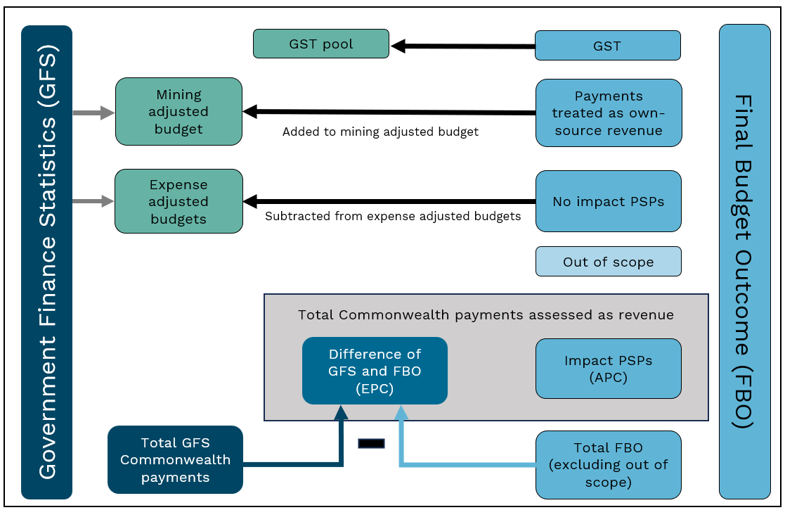

Note: PSPs (payments for specific purposes), FBO (Final Budget Outcome), APC (actual per capita), EPC (equal per capita).

## GST distribution in the 2025 Review

Table 6 shows the GST impact of the assessment in the 2025 Review.

Table 6 GST impact of the Commonwealth payments assessment, 2024–25

|  |  |  |  |  |  |  |  |  |  |
| --- | --- | --- | --- | --- | --- | --- | --- | --- | --- |
|  | NSW | Vic | Qld | WA | SA | Tas | ACT | NT | Total effect |
|  | $m | $m | $m | $m | $m | $m | $m | $m | $m |
| Commonwealth Payments | -109 | 984 | -478 | -181 | 328 | -131 | 129 | -542 | 1,442 |
| Total ($m) | -109 | 984 | -478 | -181 | 328 | -131 | 129 | -542 | 1,442 |
| Total ($pc) | -13 | 137 | -83 | -59 | 173 | -227 | 267 | -2,106 | 52 |

Note: Magnitude and direction of GST impact can change from year to year.

1. The Commonwealth payments assessment uses payment data from *Final Budget Outcome* published by the Commonwealth of Australia in conjunction with ABS Government Financial Statistics data to determine total payments from the Commonwealth.  
   Tables in this chapter, unless otherwise stated, use 2022–23 data.
2. Examples of out of scope payments include Quality Schools funding for non-government schools and funding for the Victorian Regional Rail program.