# Adjusted budget

## Overview

The adjusted budget is a comprehensive representation of state and territory (state) yearly budgets, broken down into the Commission’s category and component structure. It provides a comparable and consistent representation of revenues, expenses and investments across the states. This provides a basis to identify what a state’s revenue or expenditure may look like under average policy as part of the Commission’s assessment of GST needs.

### Scope

The adjusted budget covers all state-level financial transactions recorded in the operating statement of ABS Government Finance Statistics data. It includes activities of the general government sector, as well as public non-financial corporations that provide social housing and urban transport services.[1] A consolidation of both the general government and public non-financial corporation sectors forms the state sector for the purpose of assessing states’ GST needs.

The types of financial transactions included in the adjusted budget are:

* revenues — including taxation, fees and charges, GST, Commonwealth payments and other revenue
* expenses— including wages, non-wage expenses, interest and transfers
* investment — including transactions in non-financial assets and depreciation[2]
* net borrowing or lending — including equity acquisitions and disposals, concessional loans, borrowing and other financing transactions.

While the adjusted budget does not generally include local government transactions, state-level Government Finance Statistics data include ACT municipal transactions. The Commission treats the ACT’s municipal rate revenue as other revenue, and a portion of ACT’s municipal expenses are likely captured in the other expenses category. These are assessed equal per capita and have little or no effect on state fiscal capacities.[3] The remaining expenses are likely captured in the relevant expense categories, however, the amounts are estimated to be small. Because the inclusion of the ACT’s municipal transactions has little effect on assessed GST needs, they have been left in the data for simplicity.

## Structure

Table 1 shows the structure of the adjusted budget. It is driven by the requirements of the category and component assessments.

Table 1 Structure of the adjusted budget, 2022–23

|  |  |
| --- | --- |
| Categories / Items | Total 2022-23 |
|  | $m |
| GST revenue | 81,994 |
| Commonwealth payments | 55,834 |
| State own-source revenue (a) |  |
| Payroll tax | 34,066 |
| Land tax | 14,754 |
| Stamp duty on conveyances | 27,507 |
| Insurance tax | 7,321 |
| Motor taxes | 13,923 |
| Mining revenue | 36,342 |
| Other revenue | 47,685 |
| Total state own-source revenue | 181,597 |
| Total revenue | 319,425 |
| Less |  |
| Operating expenses |  |
| Schools (b) | 54,031 |
| Post-secondary education (b) | 7,654 |
| Health (b) | 94,650 |
| Housing (b) (c) | 2,832 |
| Welfare | 26,374 |
| Services to communities | 14,314 |
| Justice | 27,270 |
| Roads | 11,391 |
| Transport (b) (c) | 17,599 |
| Services to industry (b) | 11,624 |
| Other expenses (b) | 40,917 |
| Total expenses | 308,656 |
| Equals |  |
| Operating balance | 10,768 |
| Less |  |
| Investment (Gross) | 59,159 |
| Equals |  |
| Net borrowing (d) | -48,391 |

(a) Amounts for the ACT include municipal transactions.

(b) User charges are subtracted from expenses for these categories.

(c) Housing and urban transport include the consolidated transactions of general government and public non-financial corporation sectors.

(d) Consistent with ABS Government Finance Statistics, net borrowing is recorded as a negative number, while net lending is a positive number. It is calculated as a residual or balancing item in the adjusted budget.

## Data

### Data used in the adjusted budget

The Commission requires 5 years of data to produce relativities in an annual update. This includes data for the 3 assessment years (year 1 to year 3) and the 2 years prior to year 1 (year minus 1 and year 0).[4]

The Commission uses final Government Finance Statistics data from the ABS for year minus 1 to year 2, and preliminary ABS Government Finance Statistics data for year 3.

Preliminary ABS data are used for year 3 because the final ABS Government Finance Statistics data are not available in time for the annual update.[5] If the preliminary ABS data are not available in the time frame required, Government Finance Statistics data obtained directly from states are used instead. Final ABS data are subsequently used to replace the preliminary ABS data in the following update.

Where the Commission needs to make an adjustment to either final or preliminary ABS Government Finance Statistics data, the relevant data are requested from the ABS or states.

The adjusted budget data sources for 2025 Review and 2026 Update are shown in Figure 1.

Figure 1 Data used in each year of the adjusted budget

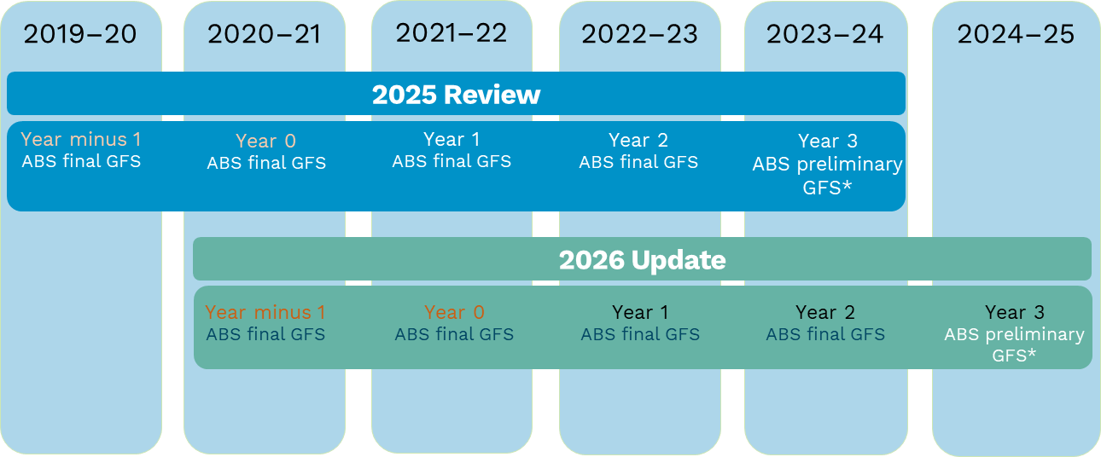

Note: *If preliminary ABS data are not available in the time frame required, state provided data are used instead.

#### Government Finance Statistics data

The Commission uses ABS Government Finance Statistics data for the state general government sector and housing and urban transport public non-financial corporations.

* General government sector data include all government units and non‑profit institutions controlled by government.
* Public non-financial corporations data include urban transport and housing government-controlled corporations and quasi‑corporations mainly engaged in the production of market goods and/or non‑financial services.[6]

Table 2 provides a summary of the data used in the 2025 Review adjusted budget compilation process.

Table 2 Data used in the adjusted budget

|  |  |  |  |
| --- | --- | --- | --- |
| Data source | Data description | How data are used | How data are obtained |
| ABS | GG and PNFC final GFS data (years minus 1 to 2) | To compile years 1 and 2 of adjusted budget. Years minus 1 to 0 are used for the investment assessment and analysis of change. | Data request |
| ABS | AASB16 (Leases) data | For an adjustment to ABS data. | Data request |
| ABS | Preliminary year 3 GG and PNFC GFS data | To compile year 3 of the adjusted budget and for various adjustments. | Data compiled by the ABS and forwarded to the Commission by states |
| States | GFS GG and PNFC data (year 3) | If ABS preliminary data are not available for a particular state by December each year, the state’s year 3 data will be used to compile year 3 of the adjusted budget. | Data request |
| States/ABS | Various data for adjustments | For various adjustments. | Data request or publicly available data |

Note: GG refers to general government; PNFC refers to public non-financial corporations; GFS refers to Government Finance Statistics; AASB16 refers to Australian Accounting Standard Board - Standard 16.

## Method

### Process for creating the adjusted budget

The Commission uses a set of code rules to classify the Government Finance Statistics data to the categories and their components. In general, data are allocated to Commission categories using the classification of the functions of government – Australia, taxes classification, economic type framework and source/destination classification codes. See Attachment A for full details.[7]

For most expense categories, the final ABS Government Finance Statistics data are used to create the component-level splits.[8] This includes the component split for the year 3 data, using the ABS year 2 data to create the components.

There are some exceptions, such as when ABS data do not include coding for the specific component splits required. In these cases, data may be requested from states or other sources to inform the split. In the case of investment, the preliminary ABS data are used to create the component splits for year 3.[9] For the services to industry category, preliminary ABS data are also used to create the component split for year 3. However, this will be monitored and may be changed to use ABS year 2 data if appropriate.[10]

To ensure the adjusted budget provides the best possible representation of states’ financial transactions across all categories, the Commission may decide to adjust Government Finance Statistics data when compiling the adjusted budget. Figure 2 shows the process for creating the adjusted budget and Figure 3 shows an example of the process for creating the adjusted budget at a category level.

Figure 2 Steps to create the adjusted budget

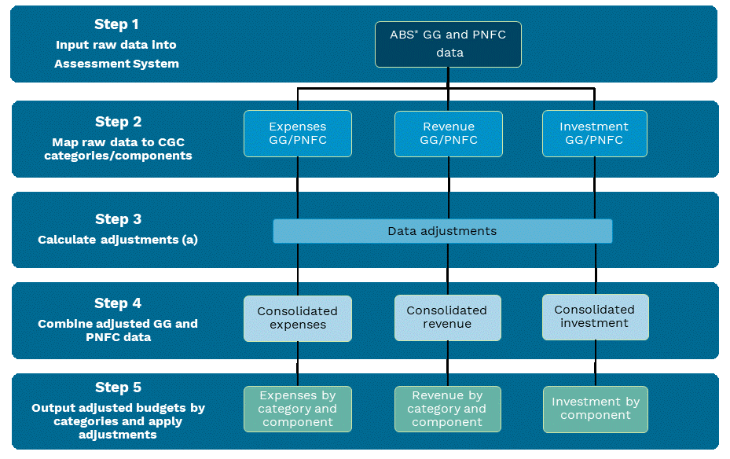

Note: * If preliminary ABS data is not available for Year 3, state data will be used instead.

GG refers to general government; PNFC refers to public non-financial corporations; CGC refers to Commonwealth Grants Commission.

(a) Some adjustments are calculated and applied during other steps in the adjusted budget compilation process.

Figure 3 Process for creating the adjusted budget at a category level – an example using the justice category

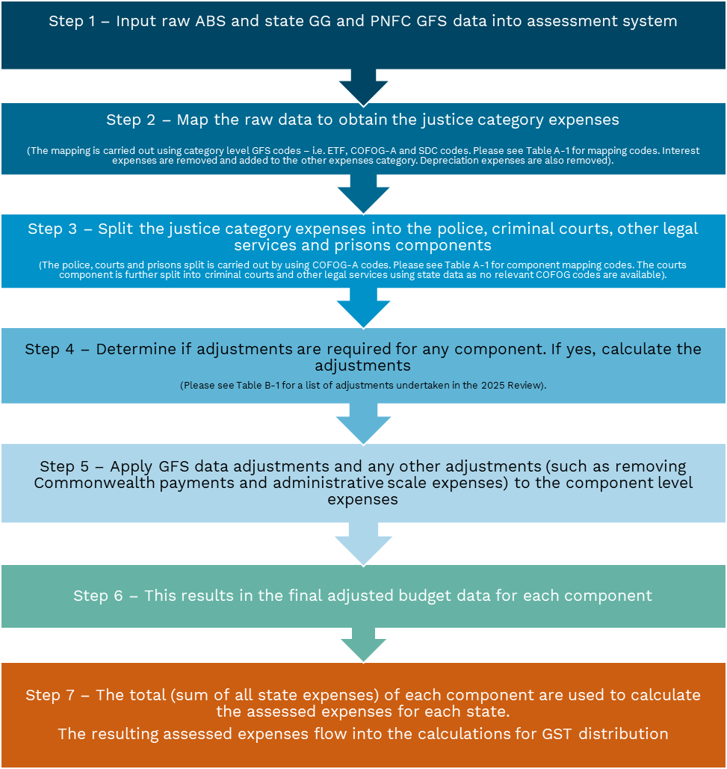

Note: GG refers to general government; PNFC refers to public non-financial corporations; GFS refers to Government Finance Statistics; ETF refers to economic type framework; COFOG-A refers to classification of the functions of government – Australia; and SDC refers to source/destination classification codes.

### Process for existing and new data adjustments

The Commission uses the process shown in Figure 4 for implementing existing and new data adjustments in the 2025 Review and subsequent updates.

Figure 4 Process for implementing data adjustments

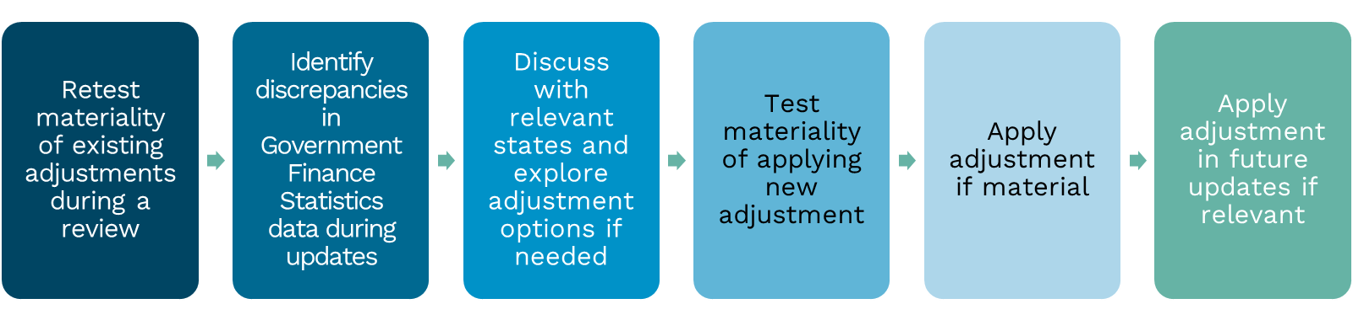

Existing adjustments

In a review year, existing adjustments are tested for materiality. An adjustment is included if it redistributes more than $12 per capita for any state in the assessment period.

Material adjustments are retained and applied in the review and subsequent updates. The materiality of these adjustments is not retested until the following review.

Immaterial adjustments are not applied. The materiality of these adjustments is not tested in subsequent updates unless new information becomes available to suggest that an adjustment has become material. States can provide such evidence through the yearly New Issues process.

New adjustments

* 1. In a review or update year, the Commission or any state can identify a new issue with Government Finance Statistics data. If an adjustment can be developed and it is material, the adjustment will be applied and retained in subsequent updates.[11] The materiality of the adjustment is not retested until the following review.
  2. When considering new adjustments, the Commission consults the relevant state(s). The consultation process is undertaken as soon as possible after a potential adjustment has been identified. If new adjustments are identified that impact most or all states, early in the update process, the Commission informs all states during the yearly New Issues process. These will likely be related to any adjustments required for the year minus 1 to year 2 ABS final data as they are received earlier than the year 3 data. Due to timing constraints, consultation on adjustments to year 3 data generally takes place in December or January.

See Attachment B for a list of the adjustments applied in the 2025 Review.

### Process for correcting data errors in prior years

Data errors discovered in previous assessment years are corrected in the corresponding assessment year of the current update. For example, an error identified in year 2 of a previous update will be corrected in year 1 of the current update (see Figure 5). The Commission will not generally make an additional adjustment to correct errors in previous year’s GST distribution as a result of data errors in previous updates. These types of retrospective adjustments are made in rare circumstances and are considered on a case-by-case basis.

Figure 5 Example of data error correction method

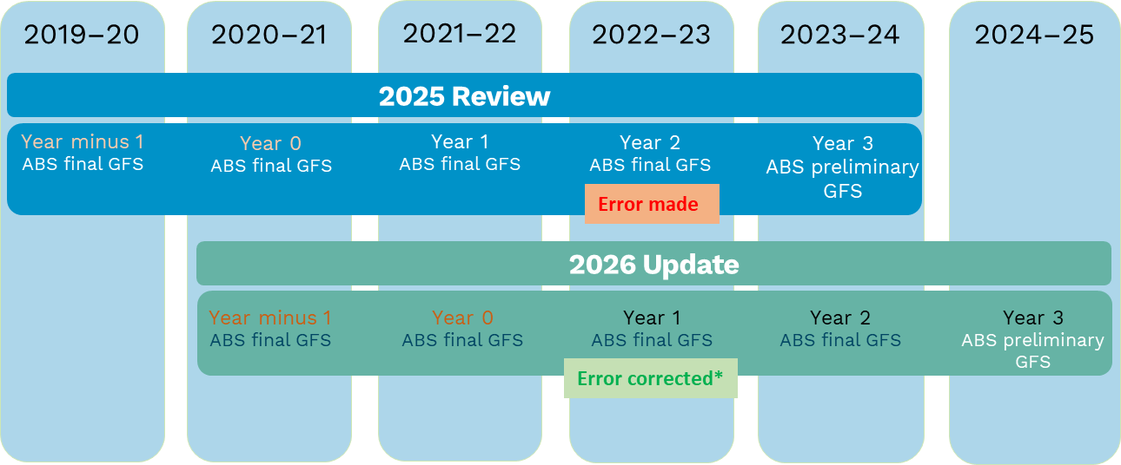

Note: *The error made in the 2022–23 assessment year in the 2025 Review is corrected in the 2022–23 assessment year in the 2026 Update. However, an adjustment to correct for the impact on GST distribution of the error in the 2025 Review is not (generally) made in the subsequent update.

## Attachment A: Code rules for mapping Government Finance Statistics data

* 1. The Commission uses a set of code rules to classify the Government Finance Statistics data to the categories and their components. For all categories, the Commission uses the following codes from the Australian System of Government Finance Statistics 2015 (AGFS15):[12]
* level of government classification (LOG) = 2 (state)
* jurisdiction classification (JUR)
* institutional sector classification (INST) = 300 (general government) other than housing and urban transport
* for housing and urban transport, INST = 300 (general government) and 100 (public non‑financial corporations, with transactions between the 2 sectors removed)
* economic type framework (ETF)
* classification of the functions of government – Australia (COFOG-A)
* taxes classification (TC)
* source destination classification (SDC)
* type of assets and liability classification (TALC) for transactions in non‑financial assets.

Table A-1 provides the code rules for general government sector transactions and Table A-2 provides the code rules for housing and urban transport, which cover transactions for both the general government and public non-financial corporation sectors.

Table A-1 Categories and their relevant Government Financial Statistics codes – general government

|  |  |  |  |
| --- | --- | --- | --- |
| Category | ETF | COFOG-A | SDC |
| Commonwealth payments | | | |
|  | 1141 Revenue from current grants and subsidies  1151 Revenue from capital grants | All | 130 Commonwealth GG |
| Payments affecting state fiscal capacities | Use figures published in the Commonwealth's Final Budget Outcome. Revenue included in this category are those payments that the Commission decided should affect state fiscal capacities. | | |
| Other Commonwealth transfers | Total Commonwealth grants less payments affecting state fiscal capacities. | | |
| Category | ETF | TC | SDC |
| Revenue |  |  |  |
| Payroll tax | 111* Taxation revenue | 211 Payroll taxes  219 Taxes on employers’ payroll and labour force n.e.c. | ≠"23" & own JUR |
| Land tax | 111* Taxation revenue | 311 Land taxes | ≠"23" & own JUR |
| Stamp duty on conveyances | 111* Taxation revenue | 463 Stamp duty on conveyances | ≠"23" & own JUR |
| Insurance tax | 111* Taxation revenue | 452 Third party insurance taxes  459 Taxes on insurance n.e.c. | ≠"23" & own JUR |
| Motor taxes | 111* Taxation revenue | 511 Stamp duty on vehicle registration  512 Road transport and maintenance taxes  513 Heavy vehicle registration fees and taxes  514 Other vehicle registration fees and taxes  519 Motor vehicle taxes n.e.c. | ≠"23" & own JUR |
| Mining revenue | 1135 Royalty income | No relevant TC | ≠"23" & own JUR |
| Other revenue | 111* Taxation revenue | 212 Superannuation guarantee charge  312 Municipal rates  313 Metropolitan improvement rates  314 Property owners' contributions to fire brigades  319 Taxes on immovable property n.e.c  321 Estate, inheritance and gift taxes  425 Agricultural production taxes  426 Levies on statutory corporations  441 Taxes on government lotteries  442 Taxes on private lotteries  443 Taxes on gambling devices  444 Casino taxes  445 Race and other sports betting taxes  449 Taxes on gambling n.e.c  451 Insurance companies' contributions to fire brigade  461 Financial institutions transactions taxes  462 Government borrowing guarantee levies  464 Stamp duty on shares and marketable securities  465 Other stamp duties on financial and capital transactions  469 Taxes on financial and capital transactions n.e.c  521 Gas franchise taxes  522 Petroleum products franchise taxes  523 Tobacco franchise taxes  524 Liquor franchise taxes  529 Franchise taxes n.e.c  534 Clean energy and related taxes | ≠"23" & own JUR |
| Category | ETF | TC | SDC |
| Revenue (continued) | | | |
| Other revenue (continued) |  | 539 Other taxes on the use of goods and performance of activities n.e.c. |  |
|  | 1131 Interest income  1132 Dividend income  1133 Withdrawals from income of quasi-corps  1134 Land rent income  1136 Revenue from investment funds  1137 Reinvestment earnings on foreign direct investment  1139 Property income n.e.c.  1142 Fines, penalties and forfeits  1143 Premiums, fees and current claims related to non-life insurance and standardised guarantee schemes  1149 Other current revenue not elsewhere classified  1152 Assets acquired below market value  1153 Capital claims related to non‑life insurance and standardised guarantee schemes  1159 Capital revenue not elsewhere classified | No relevant TC | ≠"23" & own JUR |
|  | 1141 Revenue from current grants and subsidies  1151 Revenue from capital grants | No relevant TC | ≠"23"& own JUR  and ≠"130" Commonwealth GG |
|  | 112* Sales of goods and services | No relevant TC – COFOG-As other than those included in ‘net’ categories | ≠"23" & own JUR |
| Category | ETF | COFOG-A | SDC |
| Expenses | | | |
| Schools (net) | Expenses – 12**, except 1241 Depreciation of fixed produced assets (non-defence), 1242 Depreciation of fixed assets (defence), 1271 Interest on defined benefit superannuation and 1279 Interest expenses n.e.c.  User charges – 112* Sales of goods and services | 0911 Government pre-primary education  0912 Non-government pre-primary education  0913 Government primary education  0914 Non-government primary education  0921 Government secondary education  0922 Non-government secondary education  0949 Education not definable by level n.e.c.  0959 Subsidiary services to education n.e.c.  0961 R&D - Education  0991 Special education  0999 Education n.e.c. | ≠"23" & own JUR |
| Post-secondary education (net) | Expenses – 12**, except 1241, 1242, 1271, and 1279  User charges – 112* Sales of goods and services | 0931 University education  0932 Vocational education and training  0941 Apprenticeships and traineeships | ≠"23" & own JUR |
| Health (net) | Expenses – 12**, except 1241, 1242, 1271, and 1279  User charges – 112* Sales of goods and services | 0711 Pharmaceutical products  0712 Other medical products  0713 Therapeutic appliances and equipment  0721 General medical services  0722 Specialised medical services  0723 Dental services | ≠"23" & own JUR |
| Category | ETF | COFOG-A | SDC |
| Expenses (continued) | | | |
| Health (continued) |  | 0724 Paramedical services  0731 General hospital services  0732 Specialised hospital services  0733 Medical and maternity centre services  0734 Nursing and convalescent home services  0741 Mental health institutions  0751 Community mental health services  0752 Patient transport  0759 Community health services n.e.c.  0761 Public health services  0771 R&D - health  0799 Health n.e.c. |  |
| Welfare | Expenses – 12**, except 1241, 1242, 1271, and 1279 | 1001 Sickness  1002 Disability  1011 Old age  1021 Survivors  1031 Family and children  1041 Unemployment  1069 Social exclusion n.e.c.  1071 R&D - Social protection  1099 Social protection n.e.c. | ≠"23" & own JUR |
| Services to communities | Expenses – 12**, except 1241, 1242, 1271, and 1279 | 0435 Electricity  0511 Waste recycling  0519 Waste management n.e.c  0521 Reused or recycled waste water management  0529 Waste water management n.e.c.  0531 Pollution abatement  0541 Protection of biodiversity and landscape  0551 R&D - environmental protection  0599 Environmental protection n.e.c.  0621 Indigenous community development  0629 Community development n.e.c.  0631 Water supply  0641 Street lighting  0651 R&D - Housing and community amenities  0699 Community amenities n.e.c. | ≠"23" & own JUR |
| Justice | Expenses – 12**, except 1241, 1242, 1271, and 1279 | 0311 Police services  0331 Law courts  0341 Prisons  0351 R&D - public order and safety | ≠"23" & own JUR |
| Roads | Expenses – 12**, except 1241, 1242, 1271, and 1279 | 1111 Road maintenance  1112 Road rehabilitation  1113 Road construction  1119 Road transport n.e.c. | ≠"23" & own JUR |
| Transport – non-urban transport (net); urban transport code rule is in Table A-2 | Expenses – 12**, except 1241, 1242, 1271, and 1279  User charges – 112* Sales of goods and services | 1122 Non-urban bus transport  1132 Urban water transport freight services  1133 Non-urban water transport services  1142 Non-urban railway transport freight services  1143 Non-urban railway transport passenger services  1151 Air transport  1171 Pipeline and other transport | ≠"23" & own JUR |
| Services to industry (net) | Expenses – 12**, except 1241, 1242, 1271, and 1279  User charges – 112* Sales of goods and services | 0439 Fuel and energy n.e.c.  0441 Mining of mineral resources other than mineral fuels  0442 Manufacturing  0443 Construction  0461 Distributive trades, storage and warehouse  0462 Hotels and restaurants  0463 Tourism |  |
| Category | ETF | COFOG-A | SDC |
| Expenses (continued) | | | |
| Services to industry (continued) |  | 0464 Multipurpose development projects  0471 R&D - general economic, commercial and labour affairs  0472 R&D - agriculture, forestry, fishing and hunting  0473 R&D - fuel and energy  0474 R&D - mining, manufacturing and construction  0476 R&D - other industries  0499 Economic affairs n.e.c. |  |
| Other expenses (net) | Expenses – 12**, except 1241, 1242, 1271, and 1279  User charges – 112* Sales of goods and services,  TC 314 Property owners’ contributions to fire brigades,  TC 451 Insurance companies’ contributions to fire brigades | 0111 Executive and legislative organs  0112 Financial and fiscal affairs  0113 External affairs  0121 Economic aid to developing countries and countries in transition  0122 Economic aid routed through international organisations  0131 General personnel services  0132 Overall planning and statistical services  0139 General services n.e.c.  0141 Basic research  0151 R&D - general public services  0161 Public debt transactions  0171 Transfers of a general character between difference levels of government  0199 General public services n.e.c.  0321 Civil protection services  0322 Fire protection services  0391 Control of domestic animals and livestock  0399 Public order and safety n.e.c.  0451 Communication  0475 R&D - communication  0811 Recreational and sporting services  0821 Film production services  0829 Cultural services  0831 Broadcasting and publishing services  0832 Publishing services  0841 Religious and other community services  0851 R&D - Recreation, culture and religion  0891 Community centres and halls  0899 Recreation, culture and religion n.e.c.  1091 Natural disaster relief | ≠"23" & own JUR |
| Category | ETF | COFOG-A | SDC |
| Investment | | | |
| Investment | Gross investment (that is depreciation is not deducted) for all categories except urban transport. For urban transport, depreciation is deducted from gross investment. | | |
| Transactions in non-financial produced assets (TALC 1 fixed produced assets and 2 other produced assets) | | | |
| Other than housing and urban transport | 4111 Change in inventories  4112 Acquisitions of non‑financial assets under new finance leases  4113 Own-account capital formation  4114 Acquisition of other new non-financial assets  4115 Acquisition of second‑hand non-financial assets  4211 Disposals of non-financial assets (excluding depreciation) | COFOG-As other than housing and urban transport | ≠"23" & own JUR |
| Category | ETF | COFOG-A | SDC |
| Other transactions in non-financial non produced assets (TALC 3 Non-produced assets) | | | |
|  | 4112 Acquisitions of non‑financial assets under new finance leases  4113 Own-account capital formation  4114 Acquisition of other new non‑financial assets  4115 Acquisition of second‑hand non-financial assets  4211 Disposals of non-financial assets (excluding depreciation) | COFOG-As other than housing and urban transport | ≠"23" & own JUR |

Table A-2 Housing and urban transport and their relevant Government Finance Statistics codes – consolidated GG and PNFC sectors (INST=100, 300)

|  |  |  |  |
| --- | --- | --- | --- |
| Category | ETF | COFOG-A | SDC |
| Operating expenses | | | |
| Housing (net) | Expenses – 12**, except 1241, 1242, 1271, and 1279  User charges – 112* Sales of goods and services | 0611 Housing development  0698 Housing n.e.c.  1051 Housing | ≠"23" & own JUR  and  ≠"21" & own JUR |
| Transport –  urban transport (net) | Expenses (including depreciation) – 12**, except 1242, 1271, and 1279  User charges – 112* Sales of goods and services | 0951 Transportation of non-urban school students  0952 Transportation of other students  1121 Urban bus transport  1131 Urban water transport passenger services  1141 Urban railway transport services  1161 Multi-mode urban transport  1181 R&D – transport  1199 Transport n.e.c. | ≠"23" & own JUR  and  ≠"21" & own JUR |
| Investment (gross for housing, net for urban transport) | | | |
| Transactions in non-financial produced assets (TALC 1 – fixed produced assets and TALC 2 – other produced assets) | | | |
| Housing (gross) | 4111 Change in inventories  4112 Acquisitions of non-financial assets under new finance leases  4113 Own-account capital formation  4114 Acquisition of other new non‑financial assets  4115 Acquisition of second-hand non‑financial assets  4211 Disposals of non-financial assets (excluding depreciation) | 0611 Housing development  0698 Housing n.e.c.  1051 Housing | ≠"23" & own JUR  and  ≠"21" & own JUR |
| Urban transport (net) | 4111 Change in inventories  4112 Acquisitions of non-financial assets under new finance leases  4113 Own-account capital formation  4114 Acquisition of other new non‑financial assets  4115 Acquisition of second-hand non‑financial assets  4211 Disposals of non-financial assets (excluding depreciation)  4212 Reductions in non-financial assets due to depreciation | 0951 Transportation of non-urban school students  0952 Transportation of other students  1121 Urban bus transport  1131 Urban water transport passenger services  1141 Urban railway transport services  1161 Multi-mode urban transport  1181 R&D - transport  1199 Transport n.e.c. | ≠"23" & own JUR  and  ≠"21" & own JUR |
| Other transactions in non-financial non produced assets (TALC 3 – non-produced assets) | | | | |
|  | | 4112 Acquisitions of non-financial assets under new finance leases  4113 Own-account capital formation  4114 Acquisition of other new non‑financial assets  4115 Acquisition of second-hand non‑financial assets  4211 Disposals of non-financial assets (excluding depreciation) | 0611 Housing development  0698 Housing n.e.c.  1051 Housing  0951 Transportation of non-urban school students  0952 Transportation of other students  1121 Urban bus transport  1131 Urban water transport passenger services  1141 Urban railway transport services  1161 Multi-mode urban transport  1181 R&D - transport  1199 Transport n.e.c. | ≠"23" & own JUR  and  ≠"21" & own JUR |

## Attachment B: Adjustments made to Government Finance Statistics data, 2025 Review

Table B-1 Adjustments made to Government Finance Statistics data, 2025 Review

| Adjustment Name | Description |
| --- | --- |
| Investment – roads and transport | This adjustment allocates a state’s urban transport investment expenses into the roads, urban transport and non-urban transport investment components. The state classifies all investment expenses for roads, urban transport, and non‑urban transport as urban transport investment. |
| Investment – AASB16 adjustment | An adjustment is made to include the Australian Accounting Standard Board (AASB16) leases standard in ABS final Government Finance Statistics data. An adjustment is also required for year 3 preliminary ABS data if they did not include the AASB16 standard. |
| Non-government schools Commonwealth payment adjustment | This adjustment removes the non-government schools’ proportion of the Quality Schools funding from year 3 preliminary ABS data. This funding no longer appears in states’ ABS final Government Finance Statistics data. |
| Public non-financial corporationadjustments | These adjustments reclassify some ABS public non-financial corporation data to the appropriate category and component. This adjustment mainly affects the housing category. |
| Local government and roads grants adjustment | The adjustment reclassifies some local government and roads grant expenses to the appropriate category and component. This adjustment mainly affects the roads and other expenses categories. |
| Concessions | This adjustment moves several concession expenses to the appropriate category and component. This adjustment mainly affects the welfare category. |
| Homelessness | This adjustment moves several homelessness expenses to the appropriate category and component. This adjustment mainly affects the welfare category. |
| Natural disasters adjustment | The natural disasters adjustment reclassifies the relevant natural disaster expenses of a state’s reconstruction authority to other expenses. |
| Stamp duty adjustments | The stamp duty adjustments relocate stamp duties from the sale of major state assets, corporate reconstructions and non-real property from the stamp duty on conveyances to the other revenue category. |
| Transport adjustments | The transport adjustments move some transport expenses between urban and non‑urban transport. |
| Water extraction charge | This adjustment reclassifies a state’s water abstraction charges from mining to other revenue. |
| Mining expenses adjustments | The mining expenses adjustments reclassifies mining expenses to the appropriate category and component. These adjustments mainly affect the services to industry category. |
| Mental health levy | This adjustment reclassifies a state’s mental health levy from other revenue to payroll tax. |
| Transfer of urban transport assets | This adjustment reclassifies the sign of a state’s asset transfer between GG and PNFC sectors to ensure it does not impact expenditure. |

1. Under the 2025 Review approach, activities of the Commonwealth, local government (except for the ACT), state public non‑financial corporations other than those for social housing and urban transport, state public financial corporations, and non-government entities are not included in the adjusted budget. However, the adjusted budget includes transactions between these sectors and the state sector. Also, some types of non‑state spending affect the amount states need to spend. For example, the schools and health assessments recognise the influence of non‑state sector spending.  
   The reason for including housing and urban transport services public non-financial corporations (instead of all public non‑financial corporations) is due to these 2 sectors having strong similarities to the services provided by general government agencies. They are not fully commercial and depend on government funds to meet recurrent expenses and investment. Their services stem from social policy objectives, and governments make the major policies on service delivery and charges.
2. Transactions in non-financial assets mainly include acquisitions of non-financial assets including change in inventories, acquisitions of non-financial assets under new finance leases, own-account capital formation, acquisitions of other new non‑financial assets, and acquisitions of second-hand non-financial assets. They also include disposals of non-financial assets (excluding depreciation), which are netted off acquisitions.
3. In the other expenses assessment, a regional and wage cost adjustment is applied to a share of expenses. Therefore, there is a small impact on GST needs. Other revenue is assessed equal per capita and has no impact on GST needs.
4. Data from year minus 1 and year 0 are used to derive factors for the investment assessment and for analysis of why a state’s assessed GST needs change between updates.
5. The Commission typically receives the final ABS Government Finance Statistics data, for the financial year ending in the previous calendar year (year 2), in April or May.
6. ABS, [*Glossary, Australian System of Government Finance Statistics: Concepts, Sources and Methods*](https://www.abs.gov.au/statistics/detailed-methodology-information/concepts-sources-methods/australian-system-government-finance-statistics-concepts-sources-and-methods/2015/glossary), ABS website, 2015, accessed 5 September 2023.
7. Categories relate to areas of state spending or state revenue activity. The Commission has identified 12 expenditure categories and 7 revenue categories (see Attachment A).
8. A component refers to a particular area of spending within a broader category. For example, there are 4 components within the justice category. These are police, criminal courts, other legal services and prisons.
9. Preliminary ABS data are used to derive component expenditure because investment is too volatile to estimate using year 2 ABS data.
10. Preliminary ABS data are used to create the component split for year 3 in the 2025 Review as the 2023–24 assessment year data may still contain residual amounts of COVID‑19 payments. If it is found that no COVID-19 payments are being included in the preliminary ABS data going forward, components can revert to being based on final ABS year 2 proportions.
11. New adjustments are made to all relevant assessment years in the current review or update. New adjustments are not applied retrospectively.
12. Refer to ABS catalogue *Australian System of Government Finance Statistics: Concepts, Sources and Methods 2015* for details of Government Financial Statistics concepts and definition of Government Financial Statistics codes.