**2025 Methodology Review**

Welfare consultation paper

October 2023

|  |  |
| --- | --- |
| Paper issued | 26 October 2023 |
| Commission contact officer | Peter Lock, 02 6218 5718, peter.lock@cgc.gov.au |
| Submissions sought by | 1 March 2024  Submissions should be placed in your private state channel in CGC Engagement Teams, with a post notifying Katrina Baldock.  Submissions should be in Word format and posted in the relevant state channel of the CGC engagement Team. Submissions more than 10 pages in length should include a summary section. |
| Confidential material | It is the Commission’s normal practice to make state submissions available on its website under the CC BY licence, allowing free use of content by third parties.  Creative Commons - CC BY Attribution  Further information on the CC BY licence can be found on the Creative Commons website (http://creativecommons.org).  Confidential material contained in submissions must be clearly identified or included in separate attachment/s, and details provided in the covering email. Identified confidential material will not be published on the Commission’s website. |

Contents

Overview of category 4

Current assessment method – 2020 Review 4

Data used in the assessment 5

Category and component expenses 6

GST distribution in the 2023 Update 7

What has changed since the 2020 Review? 8

Increased demand for child protection and family services 8

Expansion of state government concession programs 8

Full implementation of the NDIS, and simplified data collection 8

Increased spending and new data on homelessness services use 9

Implications for assessment 9

The full implementation of the NDIS can simplify data collection 10

Developing a homelessness services assessment 10

Simplifying the assessment by combining other welfare and non-NDIS disability services, aged care, and the National Redress Scheme 14

Proposed assessment 16

Differences from the 2020 Review approach 16

Proposed assessment structure 16

New data requirements 17

Consultation 17

## Overview of category

The welfare assessment has 5 components. They are:

* state and territory (state) expenditure associated with child protection and family services, which consists of child protection and out-of-home care
* state funding contributions to the National Disability Insurance Scheme (NDIS)
* non-NDIS disability service expenditure, state expenditure on aged care, and the National Redress Scheme for Institutional Child Sexual Abuse (National Redress Scheme)
* concessions (excluding transport concessions) for pensioner and health card holders on electricity and other energy, water and wastewater, rates, and other low-income concessions
* other welfare services including homelessness assistance, women’s shelters, and information funding and referral services.

## Current assessment method – 2020 Review

Each of the 5 components assessments has a unique assessment method.

#### Child protection and family services

The child protection and family services assessment recognises that the use and cost of providing these services is influenced by:

* the socio-demographic composition of each state’s population including children aged 0-17 years, Indigenous status, socio-economic status and location
* the differences in public sector wage costs between states
* the higher cost of providing services in regional areas
* the differences in service delivery scale costs, which reflect the high fixed costs of providing services in regional and remote areas.

The assessment estimates the average service use rate for each combination of socio-economic and Indigenous status and location categories. Average national use rates are used to estimate the policy neutral assessed service use in each state.

The distribution of assessed service use between states is then used to allocate national spending on child protection and family services between states.

Assessed state spending is then scaled by wage costs, regional and service delivery scale costs.

#### National Disability Insurance Scheme

State NDIS spending is assessed using the state’s share of the national population at the most recent Australian Bureau of Statistics (ABS) census (currently 2021). The assessment reflects the method used to determine state contributions to the NDIS at full scheme implementation.

Prior to the 2023 Update, the Commission assessed state NDIS spending using the 2011 Census populations as outlined in the intergovernmental funding agreements.

#### Non-NDIS, non-Commonwealth aged care and the National Redress Scheme for Institutional Child Sexual Abuse

Most disability and aged care services are provided by the Commonwealth. However, there are residual disability and aged care services which are provided by the states.

This spending is assessed using a non-deliberative equal per capita assessment because the Commission is not able to identify a policy neutral driver of spending.

#### Concessions

The driver of need for spending on concessions is the socio-demographic composition of state population. The need for state concession spending is based on the proportion of national concession card holders in each state.

The concession cards considered in the assessment are:

* low-income healthcare card
* pensioner concession card
* veteran concession card.

#### Other welfare services

The use of other welfare services is assessed as non-deliberative equal per capita because the Commission is not able to identify a policy neutral driver of spending.

Adjustments are made to the equal per capita distribution for the:

* differences in public sector wage costs between states
* differences in cost of providing services in regional areas
* cross-border costs incurred by the ACT Government in providing homelessness services to regional New South Wales.

### Data used in the assessment

State government spending on concessions, NDIS and non-NDIS disability services and the National Redress Scheme are collected through data requests to the states.

The number of healthcare and pension card holders is collected from publicly available Services Australia datasets. The number of veteran concession cardholders is collected from the Commonwealth Department of Veterans’ Affairs.

Spending on child protection and family services and cross-border state services is collected from the annual *Report of Government Services* published by the Productivity Commission.

The number of child protection and family service ‘substantiations’ by location and Indigenous status is sourced from the Australian Institute of Health and Welfare.[1]

State population characteristics such as age, Indigenous status and location are sourced from latest available ABS census data. These data are being continually updated to the 2021 Census as new data are released by the ABS.

Annual population statistics are sourced from the national, state and territory populations published by the ABS.

Wage, regional and service delivery scale cost factors are derived using the methods outlined in volume 2, chapter 27 – Wage costs and chapter 28 – Regional costs of the [Report on GST Revenue Sharing Relativities, 2020 Review](https://www.cgc.gov.au/reports-for-government/2020-review). Regional costs and wage factors are also subject to the current review.

### Category and component expenses

Table 1 shows total state spending on welfare services. These expenses totalled around $24 billion in 2021–22, representing 7% of total state government spending. South Australia spent the largest share of its state budget on welfare services (9.2%) while the ACT spent the smallest share (4.9%).

Table 1 Welfare expenditure by state, 2021–22

|  |  |  |  |  |  |  |  |  |  |
| --- | --- | --- | --- | --- | --- | --- | --- | --- | --- |
|  | NSW | Vic | Qld | WA | SA | Tas | ACT | NT | Total |
| Total expenditure ($m) | 7,292 | 5,824 | 4,797 | 2,683 | 2,008 | 574 | 325 | 506 | 24,009 |
| Proportion of total expenditure (%) | 6.4 | 6.2 | 8.0 | 7.8 | 9.2 | 8.2 | 4.9 | 7.8 | 7.0 |

Source: Commission calculation, 2023 Update.

State expenditure on welfare has increased 26% from $19.1 billion in 2018–19 to around $24 billion in 2021–22 (see Table 2). However, growth in other state spending has exceeded growth in welfare spending.

Table 2 Total welfare expenditure, 2021–22

|  |  |  |  |  |
| --- | --- | --- | --- | --- |
|  | 2018–19 | 2019–20 | 2020–21 | 2021–22 |
| Total expenditure ($m) | 19,110 | 21,265 | 22,245 | 24,009 |
| Proportion of total expenditure (%) | 7.3 | 7.5 | 7.2 | 7.0 |

Source: Commission calculation, 2023 Update.

The welfare assessment has 5 components. Table 3 shows the size of each component and the driver used by the Commission to assess states’ expense needs.

Table 3 Structure of the welfare assessment, 2021–22

|  |  |  |  |  |
| --- | --- | --- | --- | --- |
| Component | Component expense |  | Driver of need | Influence measured by driver |
|  | $m |  |  |  |
| Child protection and family services | 8,359 |  | Socio-demographic composition | Recognises that service use is influenced by the socio-demographic composition of the state population including those aged 0-14, Indigenous status, socio-economic status, and where people live. |
|  |  |  | Wage costs | Recognises differences in wage costs between states. |
|  |  |  | Regional costs and service delivery scale | Recognises the higher cost of providing services to regional areas within a state and to small population centres. |
| National Disability Insurance Scheme | 9,839 |  | Census population shares | Recognises that the funding agreements for the NDIS are based on each state's population at the latest census. |
| Non-NDIS disability services, aged care and National Redress Scheme | 1,517 |  | Equal per capita | Recognises that the Commission has not found a differential driver of need. This spending is assessed as a non-deliberative equal per capita assessment. |
| Concessions | 2,403 |  | Socio-demographic composition | Recognises that numbers of pensioner concession card plus health care card holders affect the use and cost of providing concessions. |
| Other welfare | 1,891 |  | Equal per capita | Recognises that the Commission has not found a differential driver of need. This spending is assessed as a non-deliberative equal per capita assessment. |
|  |  |  | Wage costs | Recognises differences in wage costs between states. |
|  |  |  | Regional costs | Recognises the higher cost of providing services to regional areas within a state. |
|  |  |  | Cross-border costs | Recognises the cost to the ACT of providing homelessness services to New South Wales residents. |

Source: Commission calculation, 2023 Update.

### GST distribution in the 2023 Update

Table 4 shows the GST impact (distribution from equal per capita) of the welfare assessment. In total the category distributed $938 million ($35 per capita) away from an equal per capita distribution in the 2023 Update. Child protection and family services was the largest category, distributing $800 million.

The welfare assessment distributed $285 million or $1,096 per capita to the Northern Territory and $81 million or $171 per capita away from the ACT.

Table 4 GST impact of the welfare assessment, 2022–23

|  |  |  |  |  |  |  |  |  |  |
| --- | --- | --- | --- | --- | --- | --- | --- | --- | --- |
|  | NSW | Vic | Qld | WA | SA | Tas | ACT | NT | Redist |
|  | $m | $m | $m | $m | $m | $m | $m | $m | $m |
| Child protection and family services | 64 | -697 | 348 | 49 | -44 | 55 | -59 | 284 | 800 |
| NDIS | -13 | -18 | 19 | 9 | 1 | 1 | 0 | 0 | 31 |
| Non-NDIS disability, aged care, and National Redress Scheme | 0 | 0 | 0 | 0 | 0 | 0 | 0 | 0 | 0 |
| Concessions | -18 | -24 | 40 | -33 | 40 | 19 | -23 | -1 | 99 |
| Other welfare | 0 | -5 | -1 | 5 | -1 | 0 | 1 | 2 | 8 |
| Total ($m) | 33 | -743 | 406 | 29 | -4 | 75 | -81 | 285 | 938 |
| Total ($pc) | 4 | -110 | 75 | 10 | -2 | 128 | -171 | 1,096 | 35 |

Source: Commission calculation, 2023 Update.

Further detail on service provision arrangements, the range of services included within this category and the underlying conceptual cases for the assessment methods are explained in volume 2, chapter 16, [Report on GST Revenue Sharing Relativities, 2020 Review.](https://www.cgc.gov.au/reports-for-government/2020-review)

## What has changed since the 2020 Review?

### Increased demand for child protection and family services

The Australian Institute of Health and Welfare said that during the COVID-19 pandemic there was an increase in the prevalence of family and domestic violence.[2] This has led to increased demand for, and spending on, child protection and family support services.[3]

### Expansion of state government concession programs

To meet the rising cost of living and support low- and middle-income households, the Commonwealth in partnership with state governments announced a $3 billion expansion to electricity and gas concessions in the 2023‑24 Budget. The package included expanded concession eligibility criteria.

### Full implementation of the NDIS, and simplified data collection

Following the expiration of the Western Australia transitional agreement on 1 July 2023, all states have fully transitioned to the NDIS.

In 2023, Western Australia will negotiate a comprehensive NDIS funding agreement with the Commonwealth. The full implementation of the scheme and the expected harmonisation of state funding contributions is expected to result in a simplification of data collection, after the agreement is negotiated.

Currently the Commonwealth, in partnership with states, is undertaking a review of the first 10 years of the NDIS. The Commission will assess any impact of the review on the assessment when it has been completed in October 2023 and the recommendations have been considered by governments.

### Increased spending and new data on homelessness services use

State spending on homelessness services has increased. Between 2017–18 and 2021‑22, state spending on homelessness services increased 37% in real terms to $1.3 billion.[4] State spending on homelessness services is likely to have increased further in 2022–23, as rising interest rates, rents and the cost of consumer staples increases demand for homelessness services.

The availability of new data from the Australian Institute of Health and Welfare on the use of homelessness services by all population subgroups (including socio‑economic status, remoteness, Indigenous status, and age) enables a broad socio‑demographic composition assessment of state government spending on homelessness services.

## Implications for assessment

The Commission has identified the following 3 issues for consideration:

* full implementation of the NDIS and simplified data collection
* development of a homelessness services assessment
* combining other welfare and non-NDIS disability services aged care and National Redress Scheme component assessments.

Although demand for child protection and family services has increased, this does not warrant a change in the assessment method because increased service use is captured through the number of substantiated cases in the existing assessment.

Similarly, while state governments have expanded concession programs for utility costs this does not warrant a change to the assessment method which covers concessions for low-income households. The Commission considers that eligibility for a low-income healthcare card, pensioner concession card and veteran concession card best reflects the driver of need for low-income concessions. The current assessment method will capture any increase in state spending on concessions for these card holders. State spending on concessions to middle and high-income households will be captured in other assessment categories, including services to communities and other expenses.

### The full implementation of the NDIS can simplify data collection

The expiration of the Western Australian NDIS transitional agreement is expected to lead to the harmonisation of NDIS funding agreements across Australia.

The harmonisation of state NDIS funding agreements, with contributions based on the national population distribution from the ABS 2021 Census, is expected to simplify the Commission’s data collection process for state NDIS contributions.

From the 2025 Review, the Commission’s preliminary view is to source NDIS funding contributions directly from the Commonwealth Budget papers and cease to collect contributions to the scheme from the states.

The Commission does not propose to change the NDIS assessment because it is currently assessed using the ABS 2021 Census population shares, in line with each state’s expected funding obligations.

#### Consultation questions

1. Do states agree that the state NDIS contributions can be collected from the Commonwealth Budget papers rather than from the states?
2. Do states agree that the current NDIS assessment is fit for purpose?

### Developing a homelessness services assessment

Homelessness services include a broad range of services targeted to prevent people becoming homeless as well as assisting those who are homeless. The Productivity Commission’s *Report on Government Services* lists homelessness services to include:

“*supported accommodation, counselling, advocacy, links to housing, health, education and employment services, outreach support, brokerage and meals services, and financial and employment assistance”*[5]

Currently, state spending on homelessness services is assessed in the ‘other welfare’ component assessment. As a result, the use of homelessness services is assessed on an equal per capita basis with adjustments for regional and wage cost factors and cross-border expenses.

However, the use of homelessness services differs between states, with homelessness services use in the Northern Territory nearly 4 times the national average (Figure 1). This indicates that an equal per capita assessment may be inappropriate.

Figure 1 Specialist Homelessness Services Clients per 10,000 people by state, 2021–22

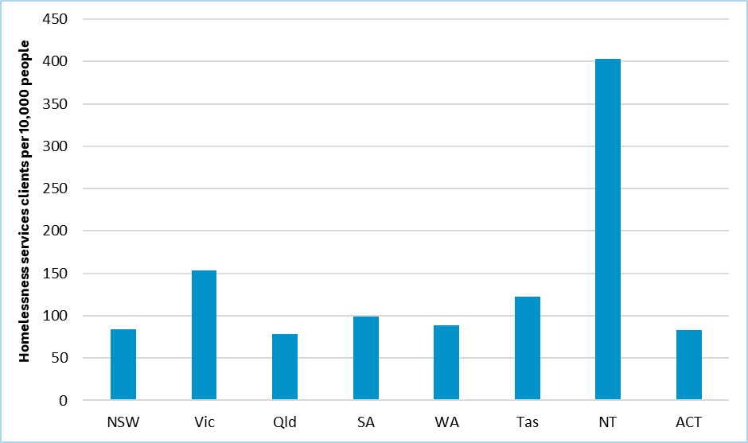 Sources: Australian Institute of Health and Welfare (AIHW), *Specialist Homelessness Services Collection, 2011–12 to 2021–22*

<https://viz.aihw.gov.au/t/Public/views/HOU331_02_Chapter-CLIENTOUTCOMES/F_CLIENTS_2> , AIHW website, 2022. Australian Bureau of Statistics (ABS), *Estimated residential population by state* <https://www.abs.gov.au/statistics/people/population/national-state-and-territory-population/latest-release>, ABS, 2023.

Prior to the 2020 Review, the Commission assessed needs for homelessness spending primarily using low socio-economic status as a driver. However, in the 2020 Review, it discontinued this, recognising that:

“*while elements partially related to the present low socio-economic status measure are important, they are not decisive… Furthermore, there are no data on the   
socio-demographic characteristics of the users of other welfare services, which include a variety of services*.”[6]

For the 2025 Review, Australian Institute of Health and Welfare data on clients using ‘specialist homelessness services’ provide the opportunity to develop an assessment that considers a broader range of drivers.

#### Drivers of spending on homelessness services

The Commission proposes to develop a homelessness services assessment using the Australian Institute of Health and Welfare data cross-classified by the key population groups using homelessness services (Figure 2). The drivers included are Indigenous status, age and socio‑economic status (income support recipients) and reflects the higher use of services by these population groups.

The assessment would consider the average use of homelessness services by people with these socio‑demographic characteristics and assess the need for state spending using the characteristics of each state’s estimated resident population.

Figure 2 Proportion of specialist homelessness services clients by socio-demographic characteristics

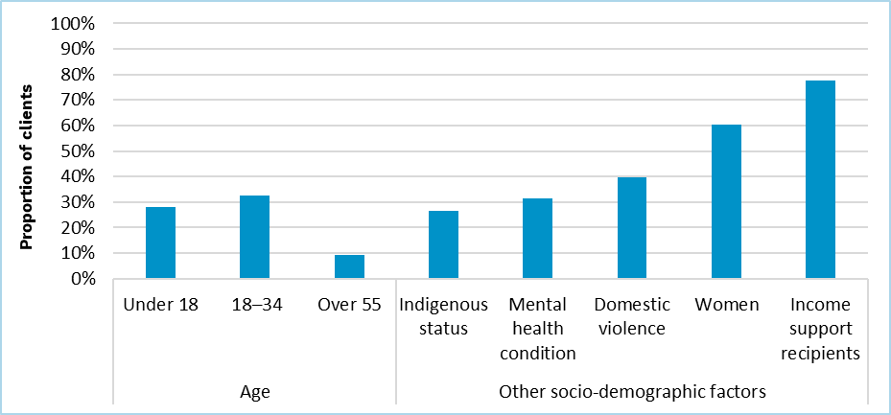

Source: Commission calculations using Australian Institute of Health and Welfare (AIHW), *Specialist Homelessness Services Collection, 2011–12 to 2021–22*, AIHW, 2022.

The Commission’s assessment would also recognise remoteness as a driver of need for state spending. People living in remote or very remote areas (aggregated to remote in Figure 3) is correlated with increased use rates of homelessness services. People in remote areas are 4 times as likely to access homelessness services when compared with population groups in major cities, despite more limited access to homelessness services (Figure 3).[7]

Figure 3 Use of specialist homelessness services by remoteness of residence

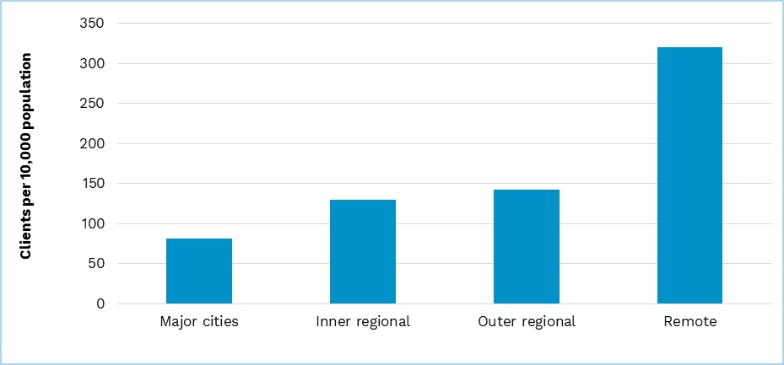

Note: Remote area classification includes areas classified as either remote or very remote in ABS remoteness areas.

Source: Commission calculation using Australian Institute of Health and Welfare (AIHW), *Specialist Homelessness Services Collection, 2011–12 to 2021–22*, AIHW, 2022.

Given the Australian Institute of Health and Welfare data (Figure 2), the Commission is also considering whether mental health can be included as a driver of need for specialist homelessness services. A key issue is whether 2021 ABS census data relating to people with a mental health condition are sufficiently reliable and   
fit-for-purpose to be used in the assessment. Further, if there are limitations with these data, consideration will be given to whether adjustments could be made to make the census data suitable for use in combination with other relevant data sources, such as the ABS’s National Survey of Mental Health and Wellbeing, National Health Survey, and Aboriginal and Torres Strait Islander Health Survey.

The Commission’s preliminary view is not to assess the need for homelessness spending using gender, because there is no material difference in the sex ratio between states.

The Commission also does not propose to include domestic violence as a driver. This is because of the lack of suitable national domestic violence data that would enable cross-classification with other population characteristics.

In summary, the Commission’s preliminary position is to assess homelessness services use using, age, Indigenous status, socio-economic status and remoteness. Further work will be undertaken on whether mental health can be included as a driver of state homelessness services spending. The timing of this work is dependent on receiving relevant data from the Australian Institute of Health and Welfare. States will be consulted separately as this work progresses and will be informed as information becomes available.

The Commission also proposes to maintain the current regional cost and wage cost factors for homelessness spending and maintain the cross-border adjustment for homelessness services provided by the ACT Government to residents of New South Wales consistent with the previous assessment.

#### Homelessness services spending data

Currently the ABS Government Financial Statistics do not separately identify state government spending on homelessness services. This reflects the complexity of homelessness services delivery with state spending on homelessness services potentially classified across many different spending categories including welfare, health, post-secondary education and housing.

To be able to adopt a homelessness services assessment in the 2025 Review, the Commission will need to be able to reliably identify state spending on homelessness services. In the first instance, the Commission will use the *Report on Government Services* data to test the materiality of a homelessness spending assessment. If the assessment is to proceed, the Commission would propose seeking relevant spending data directly from the states. To avoid double counting, the Commission would also ask states where the spending was included in Government Financial Statistics classifications.

#### Consultation questions

1. Do states support the development of a homelessness services assessment?
2. Will states be able to identify spending on homelessness services and identify where that spending is reported in the Government Finance Statistics classifications?
3. Do states support the proposed drivers to assess homelessness spending, noting further work is to be undertaken on mental health conditions as a potential driver?

### Simplifying the assessment by combining other welfare and non-NDIS disability services, aged care, and the National Redress Scheme

Currently, other welfare and non-NDIS disability services, aged care and the National Redress Scheme component assessments are assessed as equal per capita. The other welfare component also includes wage and regional cost factors and a cross-border adjustment to account for homeless services provided by the ACT Government.

In the 2020 Review, Western Australia proposed that other welfare, and non-NDIS disability services, aged care and the National Redress Scheme be assessed together. However, the Commission decided to continue the separate assessments because other welfare included allowances for regional and wage costs.

Other welfare includes wage and regional cost factors because welfare services are delivered where people live. The Commission is interested in state views on whether these factors are also relevant for non-NDIS disability services and aged care services which are also delivered at the place or community of residence.

The National Redress Scheme is not expected to be affected by regional or wage cost gradients because it is a direct payment to affected people. However, payments under the scheme are small, amounting to $128 million in 2021–22. As a result, the impact of adding regional cost or wage factors to the assessment is not material (Table 5).

Table 5 Materiality of assessing National Redress Scheme spending using regional and wage cost factors

|  |  |  |  |  |  |  |  |  |
| --- | --- | --- | --- | --- | --- | --- | --- | --- |
|  | NSW | Vic | Qld | WA | SA | Tas | ACT | NT |
| Total ($m) | 0.04 | -0.31 | -0.14 | 0.36 | -0.12 | -0.04 | 0.04 | 0.16 |
| Total ($pc) | 0.01 | -0.10 | -0.04 | 0.11 | -0.04 | -0.01 | 0.04 | 0.05 |

Source: Commission calculation based on the 2023 Update.

Subject to views from the states, the Commission’s preliminary view is to combine the other welfare and the non-NDIS disability services, aged care, and National Redress Scheme component assessments. This will simplify the assessment, reduce the reporting burden on states and will not materially impact state shares of GST.

The Commission’s preliminary view is to assess the combined expenses as equal per capita because of the lack of an identifiable driver of need, with a regional and wage cost adjustment.

Should the above changes be implemented, the Commission would stop collecting state spending on the National Redress Scheme. This is because the data request is used to separate state spending from other welfare spending prior to being assessed and will be captured by the combined assessment.

#### Consultation questions

1. Do states support combining the other welfare, non-NDIS aged care and National Redress Scheme components and assessing spending using the 2020 Review method for other welfare (equal per capita assessment method with regional and wage cost factors)?
2. Do states support the Commission ceasing to collect state spending on the National Redress Scheme?

## Proposed assessment

### Differences from the 2020 Review approach

Subject to state views, the Commission proposes to begin collecting state spending on the NDIS from the Commonwealth Budget papers following the expiration of the Western Australia transitional agreement.

The Commission also proposes to implement a new homelessness services assessment, using homelessness data from Australian Institute of Health and Welfare and data from the states if it is material.

The Commission proposes to simplify the other welfare and non-NDIS disability services, aged care, and National Redress Scheme assessments by assessing them jointly as equal per capita with regional and wage cost factors.

### Proposed assessment structure

Subject to state views, Table 6 shows the proposed structure of the welfare assessment.

Table 6 Proposed assessment structure for welfare

|  |  |  |  |  |
| --- | --- | --- | --- | --- |
| Component |  | Driver of need | Influence measured by driver | Change since 2020 Review? |
| Child protection and family services |  | Socio-demographic composition | Recognises that service use is influenced by the  socio-demographic composition of the state population including those aged 0-14, Indigenous status,  socio-economic status (SES), and where people live. | No |
|  |  | Wage costs | Recognises differences in wage costs between states. | No |
|  |  | Regional costs and service delivery scale | Recognises the cost of providing services to different areas within a state and to small population centres. | No |
| National Disability Insurance Scheme |  | Census population shares | 2021 Census population shares. | No |
| Concessions |  | Socio-demographic composition | Recognises that numbers of pensioner concession card plus health care card holders affect the use and cost of providing concessions. | No |
| Homelessness services |  | Socio-demographic composition | Recognises that that service use is influenced by the socio-demographic composition of the state population including Indigenous status, socio-economic status, age and location. | Yes |
|  |  | Wage costs | Recognises differences in wage costs between states. | Yes |
|  |  | Regional costs and service delivery scale | Recognises the cost of providing services to different areas within a state and to small population centres. | Yes |
|  |  | Cross-border costs | Recognises the cost to the ACT of providing homelessness services to New South Wales residents. | Yes |
| Other welfare including non‑NDIS, aged care, and National Redress Scheme |  | Equal per capita | This is an equal per capita assessment. | Yes |
|  | Wage costs | Recognises differences in wage costs between states. | No |
|  | Regional costs | Recognises the cost of providing services to different areas within a state. | No |

### New data requirements

As referenced in paragraph 47, the Commission proposes to obtain data on the use of homelessness services from the Australian Institute of Health and Welfare. These data will be used to assess the need for state spending on homelessness services.

As referenced in paragraph 56, the Commission will also use data from the Productivity Commission’s *Report on Government Services* on state homelessness services spending to test the materiality of a differential homelessness services assessment. If a separate assessment becomes part of the 2025 Review method, the Commission will collect state spending on homelessness services annually from states.

## Consultation

The Commission welcomes state views on the consultation questions identified in this paper (outlined below) and the proposed assessment. State submissions should accord with the 2025 Review framework. States are welcome to raise other relevant issues with the Commission.

1. Do states agree that the state NDIS contributions can be collected from the Commonwealth Budget papers rather than from the states?
2. Do states agree that the current NDIS assessment is fit for purpose?
3. Do states support the development of a homelessness services assessment?
4. Will states be able to identify spending on homelessness services and identify where that spending is reported in the Government Finance Statistics classifications?
5. Do states support the proposed drivers to assess homelessness spending, noting further work is to be undertaken on mental health conditions as a potential driver?
6. Do states support combining the other welfare, non-NDIS aged care and National Redress Scheme components and assessing spending using the 2020 Review method for other welfare (equal per capita assessment method with regional and wage cost factors)?
7. Do states support the Commission ceasing to collect state spending on the National Redress Scheme?

1. Substantiations refer to child protection notifications made to relevant authorities where, after investigation, it is concluded that there is reasonable cause to believe the child had been, was being, or was likely to be abused, neglected, or otherwise harmed.
2. Australian Institute of Health and Welfare (AIHW), *Family, domestic, and sexual violence service responses in the time of COVID‑19*, AIHW, Australian Government, 2021.
3. Steering Committee for the Review of Government Service Provision (SCRGSP), *Report on Government Services 2023*, Productivity Commission, Australian Government, 2023.
4. Steering Committee for the Review of Government Service Provision (SCRGSP), *Report on Government Services 2023*.
5. Steering Committee for the Review of Government Service Provision (SCRGSP), *Report on Government Services 2023, Part G, Section 19, Service Overview*.
6. Commonwealth Grants Commission (CGC), *Report on GST Revenue Sharing Relativities 2020 Review,* Volume 2 (Part B), p 192, CGC, Australian Government, 2020.
7. Australian Institute of Health and Welfare (AIHW), *Specialist Homelessness services annual report 2021–22: Service Geography*, AIHW, Australian Government, 2022.