**GST distribution and state investment needs**

Research paper 6

January 2023

## Summary

Investment in public infrastructure is a significant expense for states and territories (states). In 2020–21 infrastructure spending accounted for 15% of total state expenditure.

The Commission considers states’ different investment needs as part of determining a state’s capacity to meet its spending needs (fiscal capacity), which underpins the GST distribution.

The Commission’s assessment of a state’s need to invest in a particular type of infrastructure is largely based on the proportion of its population expected to use that infrastructure and how that population changes. It considers this to be the best way to remove the influence of state policy choices on investment spending.

A state may have a share of users of a particular infrastructure type that is different from its share of the national population. This influences how the Commission determines investment needs. If the number of people who use a type of infrastructure grows at a rate faster in one state than in other states, the Commission will assess this state to have a greater need for investment. In turn, states with higher investment needs will have higher GST requirements.

The Commission’s assessment of investment needs can also be influenced by the amount states collectively invest in a type of infrastructure for a particular year.

## Introduction

In determining states’ fiscal capacities, the Commission assesses how expenditure needs vary across states. This, combined with an assessment of states’ capacities to raise revenue, determines the share of the GST pool each state requires so that it can provide a similar level of services.

A significant proportion of state budgets relates to investment in public infrastructure, which in turn underpins the delivery of state services. The Commission includes this type of spending in its assessment of state fiscal capacities.

Investment spending includes large upfront costs associated with public works programs, such as building new schools. This spending can vary significantly from year to year as state investment programs ramp up and down. In contrast, ongoing expenses tend not to have large annual changes. Consequently, these two forms of spending are assessed separately because often different factors drive their costs.

State government investment in infrastructure can be driven by multiple factors, such as:

* responding to changes in population characteristics
* addressing historical underinvestment
* aligning with national frameworks or agreements made with the Commonwealth
* fulfilling a specific policy agenda, including responding to congestion.

In 2020–21, 15% of all state expenditure was for investment purposes. This proportion varied by state (Table 1).

Table 1 Actual state expenditure, 2020–21

|  |  |  |  |  |  |  |  |  |  |
| --- | --- | --- | --- | --- | --- | --- | --- | --- | --- |
|  | **NSW** | **Vic** | **Qld** | **WA** | **SA** | **Tas** | **ACT** | **NT** | **Total** |
| Investment expenditure ($m) | 16,688 | 16,729 | 7,248 | 3,125 | 2,411 | 438 | 623 | 670 | 47,931 |
| Total expenditure ($m) | 94,522 | 87,024 | 55,964 | 33,479 | 20,143 | 6,297 | 5,879 | 6,360 | 309,668 |
| **Investment as a proportion of total expenditure (%)** | **18** | **19** | **13** | **9** | **12** | **7** | **11** | **11** | **15** |

Source: State data, 2022 Update.

Figure 1 presents a breakdown of the types of state investment in Australia and shows the contribution of each to total investment expenditure. In 2020–21, urban transport, health, roads and schools accounted for about 75% of all state investment in public infrastructure.

Figure 1 Breakdown of state investment by investment type, 2020–21



1. ‘Other categories’ includes land, non-urban transport, post-secondary education, services to communities, services to industry and welfare. These areas of state investment each contribute less than 2% of the national total investment spend.

Source: State data, 2022 Update.

Current and projected population numbers are major considerations in state decisions on the type and level of investment in public infrastructure.[1] Population affects two types of state investment:

* States invest in infrastructure for new users. For example, a state with a growing population may invest in more hospitals to avoid overcrowding in current hospitals.
* States replace assets or purchase new assets for the existing users of the asset. For example, a state might invest in new train carriages to replace those that no longer function efficiently, or to improve passenger comfort.

Decisions on how much to invest in public infrastructure are largely a policy matter for state governments. The Commission, in assessing investment needs, looks for drivers of investment that are beyond states’ control to remove the influence of state policy choices. Accordingly, it has concluded that population is the most policy neutral driver of state investment needs.

The size of the population that uses types of infrastructure (referred to as the ‘user‑population’[2]) differs from state to state, as does the growth rate of this population. A state with a higher user-population growth rate than the national average will be assessed as needing to invest more in infrastructure than a state with a lower growth rate.

This paper describes how the Commission assesses state investment needs. It uses the schools investment assessment to show how the Commission’s assessment of a state’s investment needs can change from year to year.

## Shape Description automatically generatedThe investment assessment: a framework

The Commission’s task is to determine every year how much more or less than the average each state needs to spend to provide the average level of infrastructure. This assessment is not based on how much an individual state actually spends, but rather how much it needs to spend to achieve the average level of infrastructure across Australia (based on its population’s size and needs).

States have different investment needs because of differences between states in:

* the user-population of each asset type, and the degree to which that population changes during the year
* the unit cost of building such infrastructure.

The Commission measures the difference between the size of the population estimated to use an asset at the start and at the end of the year.

A state with above‑average growth in its user‑population is assessed as requiring more investment than one with below-average growth.

In the case of the schools investment assessment, the user‑population relates to the number of students enrolled in government schools.[3] Figure 2 shows how changes in user‑populations are used to determine GST requirements, using the schools investment assessment as an example.

Figure 2 Illustration of schools investment assessment method

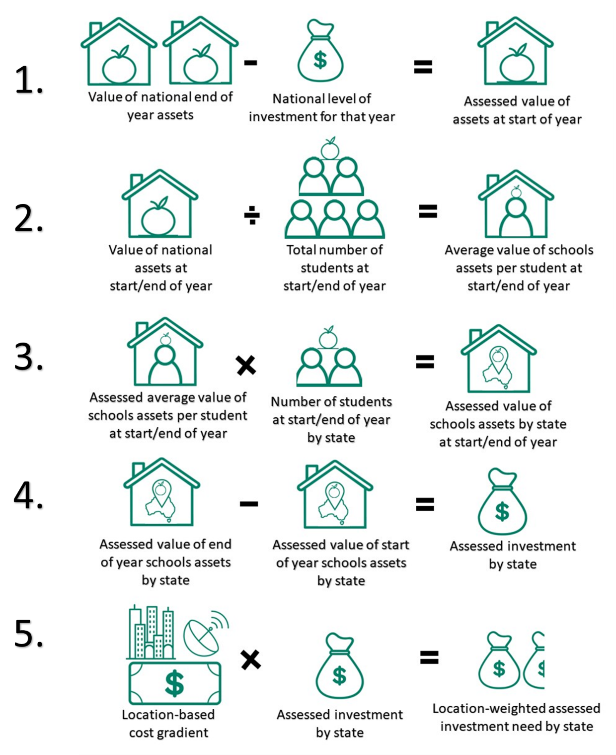

Source: 2020 Methodology Review.

The Commission collects data from each state on the value of its infrastructure assets at the end of each financial year, and the total amount it invested in infrastructure that year. These are actual data collected from all states on an annual basis by function.[4] For the schools investment assessment, the Commission requests the total value of each state’s school infrastructure, and how much it has invested in new school infrastructure and assets.

By combining all state data, the Commission determines:

* the national level of investment for the year
* the value of all assets at the end of the year
* the assessed value of all assets at the start of the year by taking the difference of the two (Step 1, Figure 2).

Step 2 of Figure 2 shows how the Commission calculates the average asset value per student at the start and end of the year. It divides the national value of assets by the total number of students.

Table 2 shows that the total value of schools’ assets across Australia was estimated to be about $68 billion at the beginning of 2020–21 (opening stock) and the total number of government school students (user‑population) at the start of the year was estimated to be about 2.59 million. This means the average asset value per student at the start of the year was $26,354.

A similar calculation gives the average asset value per student at the end of the year. The total value of schools’ assets at the end of 2020–21 (closing stock, $73 billion) is divided by the number of government school students at the end of the year (2.62 million). This means the average asset value per student across Australia at the end of the year was $27,966.

Table 2 User-population and stock in assessed schools investment, 2020–21

|  |  |  |  |  |  |  |  |  |  |
| --- | --- | --- | --- | --- | --- | --- | --- | --- | --- |
|  | NSW | Vic | Qld | WA | SA | Tas | ACT | NT | Total |
| Opening user-population ('000) | 806 | 627 | 563 | 285 | 175 | 56 | 44 | 34 | 2,590 |
| Opening stock ($m) |  |  |  |  |  |  |  |  | 68,267 |
| Stock per user at start of year ($) |  |  |  |  |  |  |  |  | 26,354 |
| Assessed value of opening stock ($m) | 21,237 | 16,515 | 14,827 | 7,516 | 4,623 | 1,488 | 1,153 | 909 | 68,267 |
| Closing user-population ('000) | 810 | 637 | 576 | 290 | 175 | 56 | 45 | 35 | 2,625 |
| Closing stock ($m) |  |  |  |  |  |  |  |  | 73,403 |
| Stock per user at end of year ($) |  |  |  |  |  |  |  |  | 27,966 |
| Assessed value of closing stock ($m) | 22,659 | 17,813 | 16,097 | 8,117 | 4,901 | 1,578 | 1,261 | 979 | 73,403 |
| Assessed investment ($m) | 1,422 | 1,298 | 1,270 | 600 | 277 | 90 | 108 | 71 | 5,136 |
| Assessed investment ($pc) | 174 | 195 | 245 | 225 | 157 | 166 | 249 | 287 | 200 |

Source: Commission calculation, 2022 Update.

In this example, the average value of assets per student across Australia grew by $1,612 in 2020–21.

The Commission next determines the assessed value of the opening and closing stock of assets held by each state (Step 3, Figure 2). This is the value of assets each state needed to hold to meet the average value of assets per student across Australia rather than the actual value. To do this, the Commission multiplies the average value of assets per student in Australia at the start and end of a year by each state’s user‑population (the number of students). In 2020–21 New South Wales is assessed to have an opening stock value of $21,237 million and a closing stock value of $22,659 million.[5]

The difference between the assessed value of each state’s opening and closing stock is the level of investment needed by each state (Step 4, Figure 2). For example, in 2020–21 New South Wales is assessed to require $1,422 million of investment for school infrastructure.[6]

### Annual population growth and capital improvements drive state investment needs

needs captures two main drivers: population growth and capital improvements.

* Population growth. A state with fast population growth will require more investment. For example, Queensland’s student population grew by nearly 13,000 in 2020–‍21, accounting for 38% of all growth in the national student population (Table 2). It required additional investment to provide each of these new students with $26,354 of school infrastructure.
* Capital improvements. In 2020–21, the average value of schools’ infrastructure increased by $1,612 per student, from $26,354 to $27,966. All states required an additional investment of $1,612 per student for capital improvements (Table 2).[7] The distribution of GST in response to this increased need for investment is allocated based on the number of students in each state.

The Commission also considers differences between states in the costs of construction (Step 5, Figure 2), but these effects have not been presented in Table 2 for illustrative purposes because they are small in comparison. The factors affecting costs of construction are more stable than those influencing a state’s annual user-population growth rate or the average value of infrastructure type per user across Australia. Therefore, they have less effect on changing investment needs.

Construction in remote areas is generally more expensive than in cities or inner regional areas because of the costs of transporting materials and attracting qualified labour. Geographically large states with dispersed remote populations, such as the Northern Territory, Queensland and Western Australia, experience larger location-based costs than less dispersed states.

There are also differences between capital cities.[8] For example, construction costs in Canberra are about 10% more expensive than in Brisbane.

### Impact of investment on GST distribution

Table 3 presents the main drivers of difference in each state’s assessed GST requirement for all investment types in 2022–23.

The difference in the GST requirement of a state reflects the difference between:

* the amount of investment needed to provide the average level of infrastructure (accounting for factors beyond its control)
* the amount of GST a state would receive if GST revenue was distributed on an equal per capita (EPC) basis.

Since the GST requirement of each state is based on a national average, changes in one state also affect the GST requirements of other states.

For example, states with population growth above the national average across all assessment years[9] have higher needs. From the end of 2017–18 to the end of 2020–21 Victoria’s and Queensland’s populations grew by 4.2% and 4.6%, respectively. This was above the national growth rate of 3.7% during this same period. For this reason, Victoria and Queensland were assessed to need $399 million and $420 million more respectively than an EPC distribution.

All other states were assessed to require less than an EPC distribution for infrastructure investment because the population growth rates of these states were below the national average from the end of 2017–18 to the end of 2020–21.

Drivers of difference from an EPC distribution of GST for all investment types, 2022–23

|  |  |  |  |  |  |  |  |  |  |
| --- | --- | --- | --- | --- | --- | --- | --- | --- | --- |
|  | NSW | Vic | Qld | WA | SA | Tas | ACT | NT | Redist |
|  | $m | $m | $m | $m | $m | $m | $m | $m | $m |
| Population growth | -371 | 399 | 420 | -23 | -278 | -57 | -18 | -72 | 819 |
| Capital improvements | 319 | -403 | -75 | 142 | -131 | -88 | -161 | 398 | 858 |
| Cost of construction | 238 | -625 | -128 | 413 | -25 | -50 | 16 | 161 | 827 |
| Total | 186 | -628 | 218 | 531 | -435 | -194 | -164 | 486 | 1,421 |
|  | $pc | $pc | $pc | $pc | $pc | $pc | $pc | $pc | $pc |
| Population growth | -45 | 59 | 79 | -8 | -155 | -103 | -42 | -287 | 32 |
| Capital improvements | 39 | -60 | -14 | 52 | -73 | -160 | -369 | 1,584 | 33 |
| Cost of construction | 29 | -93 | -24 | 152 | -14 | -90 | 36 | 642 | 32 |
| Total | 23 | -94 | 41 | 195 | -243 | -353 | -375 | 1,938 | 55 |

Note: In terms of language used in the 2020 Methodology Review, population growth relates to capital requirements and the cost of construction relates to capital costs.

Source: Commission calculation, 2022 Update.

Between the end of 2017–18 to the end of 2020–21, states collectively invested heavily in improving urban transport and rural roads. States with above‑average shares of their population in large, dense urban centres, or with requirements for extensive rural road networks required more GST to provide the national average level of capital improvements.

For New South Wales (assessed to need $319 million more GST than an EPC distribution for capital improvements in 2022–23, Table 3), this was driven by urban transport. For Western Australia ($142 million) and the Northern Territory ($398 million), it was driven by rural roads.

High construction costs in New South Wales, Western Australia and the Northern Territory also contributed to the investment related change in GST distribution.

Table 4 presents a breakdown of the impact on GST distribution for each type of state investment.

Table 4 Difference from an EPC distribution of GST by investment type, 2022–23

|  |  |  |  |  |  |  |  |  |  |
| --- | --- | --- | --- | --- | --- | --- | --- | --- | --- |
|  | NSW | Vic | Qld | WA | SA | Tas | ACT | NT | Redist |
|  | $m | $m | $m | $m | $m | $m | $m | $m | $m |
| Schools | -138 | -73 | 140 | 95 | -43 | -21 | 21 | 20 | 275 |
| Post-secondary education | 1 | -2 | 3 | 3 | -2 | -1 | -1 | -1 | 6 |
| Health | -72 | -226 | 100 | 56 | 28 | 50 | -2 | 66 | 300 |
| Housing | -31 | -4 | 51 | 9 | -11 | -4 | -6 | -3 | 59 |
| Welfare | 4 | -11 | 3 | 2 | 0 | 1 | 0 | 2 | 11 |
| Services to communities | -2 | -4 | 6 | 5 | -4 | -1 | 0 | -1 | 12 |
| Justice | -22 | -133 | 30 | 35 | -1 | 11 | -14 | 94 | 171 |
| Rural roads | -496 | -922 | 456 | 537 | 88 | 8 | -94 | 423 | 1,512 |
| Urban roads | 32 | -118 | 171 | 55 | -107 | -42 | 25 | -15 | 282 |
| Urban transport | 932 | 899 | -752 | -334 | -365 | -190 | -92 | -99 | 1,832 |
| Non-urban transport | -1 | 0 | 1 | 0 | 0 | 0 | 0 | 0 | 1 |
| Services to industry | -11 | -22 | -17 | 50 | -3 | 1 | -1 | 3 | 54 |
| Other expenses | -10 | -13 | 25 | 19 | -14 | -5 | 1 | -3 | 45 |
| Land | 0 | 0 | 0 | 0 | 0 | 0 | 0 | 0 | 0 |
| Total | 186 | -628 | 218 | 531 | -435 | -194 | -164 | 486 | 1,421 |

Source: Commission calculation, 2022 Update.

contributing to differences in the distribution of GST between the states. This reflects the large amount of state investment in these areas as well as big differences between states in their underlying need for these types of investment.

For example, in 2020–21 the total amount invested in schools was comparable to that invested in rural roads (both approximately $5 billion), yet there was a large difference in how the investment in each type influenced GST distribution. The difference between the assessed needs for schools investment and an equal per capita distribution was $275 million, while for rural roads investment the difference was $1,512 million.

The distribution (both in magnitude and across states) differs between investment in schools and rural roads because the factors used to identify the underlying demand for investment in each infrastructure type are different. In the case of school investment, each state’s share of government school students is close to its share of total population. There is therefore less difference in school investment requirements across states.

In the case of roads, the main factor influencing the assessment of states’ investment requirements is related to the length of their rural road network. There is significant variance between the states in their road investment requirements because road length is more closely connected to the geographical characteristics of a state than to its population share.

## Conclusion

public infrastructure is a significant expense for states. The Commission’s assessment of state investment needs recognises that a state’s requirements for different types of infrastructure change with its circumstances. These differences can have a significant impact on the distribution of GST.

Change in user-populations is a significant driver of assessed state investment need. Population growth captures the increase in state investment needed to provide infrastructure to new users. For schools, the Commission assesses a state with an above‑average increase in the number of students to have greater investment needs.

Population levels capture the requirement for states to replace assets and purchase improved infrastructure for existing users. A state with a larger national share of the user‑population for an infrastructure type is assessed to have greater investment needs for replacing assets of that type.

States have different investment needs because of differences between states in the populations who use the different types of infrastructure.

Differences in construction costs caused by factors like the cost of transporting materials to remote areas can also affect investment needs.

1. Australian Government Centre for Population, (2020) *The National Population and Planning Framework*, accessed 6 July 2022. <https://population.gov.au/sites/population.gov.au/files/2021-09/framework.pdf>
2. The user-population conveys the underlying need or demand for an asset and does not necessarily relate to the actual number of people using a type of infrastructure.
3. While the number of government school students is the main driver of schools investment needs, an adjustment is also applied to capture the additional costs of providing assets to schools with more than 25% enrolments of students who identify as Aboriginal and/or Torres Strait Islander. These types of adjustments are common across user-populations in the investment assessment and reflect differing levels of need among users.
4. ‘Function’ refers to the types of public services in which state governments invest. There are 13 functions of investment in public infrastructure, covering state expenditure on schools, post‑secondary education, health, housing, welfare, services to communities, justice, rural roads, urban roads, urban transport, non-urban transport, services to industry and other expenses.
5. The opening stock calculation is as follows: 805,813 students x $26,354 per student = $21,237 million

   The closing stock calculation is as follows: 810,209 students x $27,966 per student = $22,659 million
6. The assessed investment calculation is as follows: $22,659 million - $21,237 million = $1,422 million
7. Each new student is allocated the average asset value held by each user at the start of the year as well as the increase in the average value of schools infrastructure by the end of the year ($27,966 = $26,354 + $1,612).
8. This comparison is sourced from the *Australian Construction Handbook* (Rawlinsons Publishing, 2022) and is a comprehensive consideration of the average tender wage, building price indices and the building costs per square metre across all capital cities.
9. The Commission makes its assessment based on state investment needs averaged over 3 assessment years. For 2022–23, the application year of the 2022 Update, the assessment years were 2018–19, 2019–20 and 2020–21. For this reason, GST distribution is particularly sensitive to changes between the most recent financial year that is no longer assessed and the most recent assessment year. In the 2022 Update these were 2017–18 and 2020–21 respectively.