### Western Australia

This fact sheet provides a summary of the major causes of change in relative fiscal capacity since the 2019 Update, as well as an overview of circumstances that have affected expenditure and revenue.

#### Fiscal circumstances

Western Australia has the strongest fiscal capacity among the States, mainly due to its above average capacity to raise mining revenue and payroll tax.

These effects on its fiscal capacity are partly offset by high expense requirements due to above average shares of Indigenous people and people in remote areas.

Western Australia also has above average wage costs and below average non-State provision of health and school services.

Illustrative GST, Western Australia, 2020‑21

|  |  |  |
| --- | --- | --- |
|  | $m | $pc |
| Equal per capita share | 6,893 | 2,598 |
| Effect of assessed: |  |  |
| Expenses | 1,412 | 532 |
| Investment | -136 | -51 |
| Net borrowing | 86 | 32 |
| Revenue | -5,149 | -1,941 |
| Commonwealth payments | 0 | 0 |
| Illustrative GST | 3,105 | 1,170 |

Note: Table may not add due to rounding. For expenses and investment, a negative sign indicates below average costs, which reduces a State’s GST requirement. For net borrowing, revenue and Commonwealth payments, a negative sign indicates above average revenue raising capacity, which also reduces a State’s GST requirement.

|  |
| --- |
| **Key reasons why fiscal capacities differ between States**   * The uneven distribution of mining activity and production due to underlying differences in distribution of mineral reserves across Australia. * Differences in the spatial distribution (or dispersion) of their populations. * States with a greater than average share of population in less accessible regions face higher than average service delivery and infrastructure costs. * States with large, densely populated cities face higher than average urban public transport costs. * Variation in the value of property sales. States with higher property values and volume of turnover have a greater capacity to raise revenue from taxes imposed on the transfer of property. * Differences in the number of Indigenous people in their populations. States with a greater than average share of Indigenous people in the population face higher than average service delivery costs. |

#### Change in fiscal capacity

Western Australia’s fiscal capacity has strengthened due to a further increase in its capacity to raise iron ore royalties, lower assessed costs of providing urban public transport services, and revised data on the value of property sales. These changes were partly offset by below average growth in taxable land values and taxable payrolls, revisions to State natural disaster relief expenses and above average mining regulation expenses.

Western Australia’s stronger fiscal capacity will reduce its GST share from 5.3% to 4.6%. Growth in the GST pool does not offset the impact of the State’s improved fiscal capacity, and its GST entitlement will fall by $385 million, or 11.0%.

Change in illustrative GST distribution since the 2019 Update, Western Australia

|  |  |  |  |  |
| --- | --- | --- | --- | --- |
|  | | $m | | $pc |
| New population | -26 | | -10 | |
| Growth in GST available | 116 | | 44 | |
| Changes in relative fiscal capacity | -475 | | -179 | |
| Method changes | -114 | | -43 | |
| Data revisions | -31 | | -12 | |
| State circumstances | -330 | | -124 | |
| Total change | -385 | | -145 | |

Notes: Table may not add due to rounding.

The Commonwealth will be making supplementary payments to Western Australia to deliver an outcome equivalent to a relativity of 0.7.

Since the 2019 Update, there have been changes in some of the assessment methods used by the Commission, revisions to some of the data used in the assessments, and changes in economic and demographic circumstances.

Main changes for Western Australia, 2020 Review

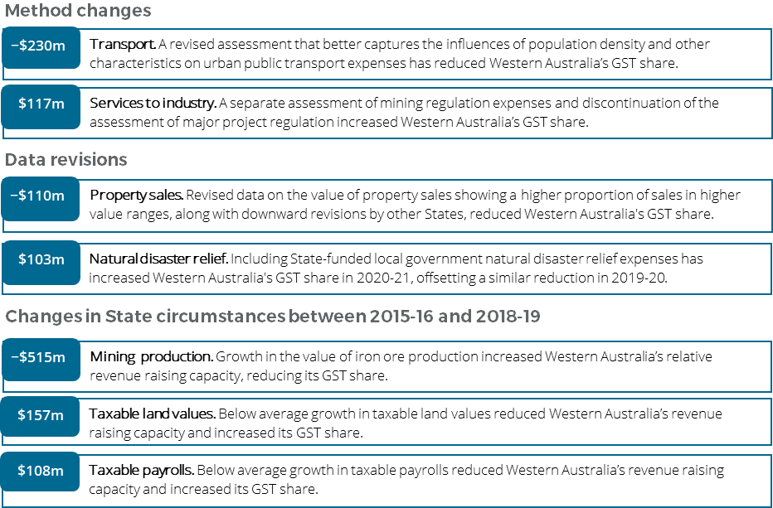

**For more information about these changes, see Volume 1 of the 2020 Review final report.**