### Northern Territory

This fact sheet provides an overview of circumstances that have affected expenditure and revenue, as well as a summary of the major causes of change in relative fiscal capacity since the 2019 Update.

#### Fiscal circumstances

The Northern Territory is the fiscally weakest State. This primarily reflects its well above average expense requirement due to above average shares of high cost population groups, including exceptionally high proportions of Indigenous people and people living in remote areas.

It also faces diseconomies of scale in administration. These effects are reinforced by its above average investment requirement, mainly for rural roads.

The Northern Territory’s above average need for assistance is partially met through an above average share of Commonwealth payments.

Illustrative GST, Northern Territory, 2020‑21

|  |  |  |
| --- | --- | --- |
|  | $m | $pc |
| Equal per capita share | 639 | 2,598 |
| Effect of assessed: |  |  |
| Expenses | 2,415 | 9,817 |
| Investment | 394 | 1,603 |
| Net borrowing | 15 | 61 |
| Revenue | 1 | 6 |
| Commonwealth payments | -412 | -1,675 |
| Illustrative GST | 3,053 | 12,410 |

Note: Table may not add due to rounding. For expenses and investment, a negative sign indicates below average costs, which reduces a State’s GST requirement. For net borrowing, revenue and Commonwealth payments, a negative sign indicates above average revenue raising capacity, which also reduces a State’s GST requirement.

|  |
| --- |
| **Key reasons why fiscal capacities differ between States**   * The uneven distribution of mining activity and production due to underlying differences in distribution of mineral reserves across Australia. * Differences in the spatial distribution (or dispersion) of their populations. * States with a greater than average share of population in less accessible regions face higher than average service delivery and infrastructure costs. * States with large, densely populated cities face higher than average urban public transport costs. * Variation in the value of property sales. States with higher property values and volume of turnover have a greater capacity to raise revenue from taxes imposed on the transfer of property. * Differences in the number of Indigenous people in their populations. States with a greater than average share of Indigenous people in the population face higher than average service delivery costs. |

#### Change in fiscal capacity

The Northern Territory’s fiscal capacity has weakened due to higher assessed investment needs for health and rural roads, an increase in assessed administrative scale costs and a relative increase in the cost of providing services to Indigenous people. These changes were partly offset by a decrease in its assessed utility subsidies and Indigenous community development expenses.

The Northern Territory’s weaker fiscal capacity will see its GST share increase from 4.1% to 4.5%. Combined with pool growth, its GST entitlement will rise by $368 million, or 13.7%.

Change in illustrative GST distribution since the 2019 Update, Northern Territory

|  |  |  |
| --- | --- | --- |
|  | $m | $pc |
| New population | -42 | -169 |
| Growth in GST available | 89 | 361 |
| Changes in relative fiscal capacity | 320 | 1,302 |
| Method changes | 272 | 1,108 |
| Data revisions | -18 | -73 |
| State circumstances | 66 | 268 |
| Total change | 368 | 1,495 |

Note: Table may not add due to rounding.

Since the 2019 Update, there have been changes in some of the assessment methods used by the Commission, revisions to some of the data used in the assessments, and changes in economic and demographic circumstances.

Main changes for Northern Territory, 2020 Review

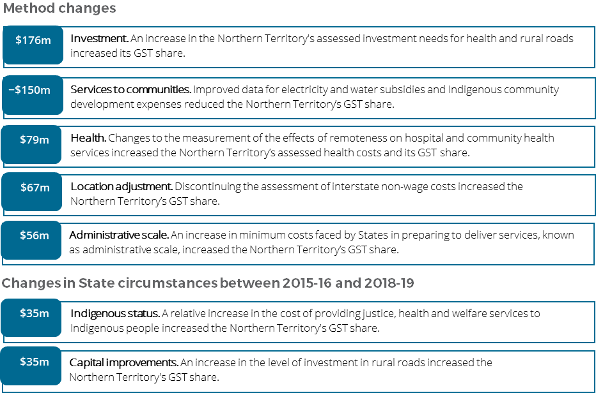

For more information about these changes, see Volume 1 of the 2020 Review final report.