

**2020 REVIEW**

**OVERVIEW TO THE 2020 REVIEW STAFF DRAFT ASSESSMENT PAPERS**

**STAFF DRAFT ASSESSMENT PAPER  
CGC 2018-01/01-S**

**APRIL 2018**

|  |  |
| --- | --- |
| Paper issued | 20 April 2018 |
| Commission contact officer | Marc Boisseau, Marc.Boisseau@cgc.gov.au |
| Submissions sought by | 31 August 2018.  Submissions should be emailed in Word format to [secretary@cgc.gov.au](mailto:secretary@cgc.gov.au).  Submissions of more than 10 pages in length should include a summary section. |
| Confidential material | It is the Commission’s normal practice to make State submissions available on its website under the CC BY licence, allowing free use of content by third parties.  Creative Commons - CC BY Attribution  Further information on the CC BY licence can be found on the [Creative Commons website](http://creativecommons.org/licenses/by/3.0) (http://creativecommons.org).  Confidential material contained in submissions must be clearly identified or included in separate attachment/s, and details provided in the covering email. Identified confidential material will not be published on the Commission’s website. |

### Contents

INTRODUCTION 1

Proposed scope of activities and category structure 1

Proposed disability assessments 2

Seeking State views 4

Attachment A – Assessment framework 5

Attachment B – GST Redistribution 12

### INTRODUCTION

* 1. In the 2020 Review work plan, the Commission advised States it would send out preliminary staff papers to States on scope and structure, treatment of Commonwealth payments, and category and factor assessments by the end of April 2018. These issues are covered in a suite of staff papers, which include:
* an overview to the draft assessment papers (this paper)
* draft assessment papers for each category and common factors
* a research paper on a broader assessment approach
* a discussion paper on the quality assurance strategy.
  1. These papers set out **staff views** on category and factor assessments for the 2020 Review. Not all aspects of assessments are addressed. Where they are not discussed, States should assume that Commission staff are not proposing to recommend changes to the Commission.
  2. Staff have used State views from the 2015 Review, State comments on the Staff Research Papers (What States do papers), and the October/November telepresence discussions to help identify issues.

### Proposed scope of activities and category structure

* 1. The scope of State activities covered in the draft assessment papers is the same as that of the 2015 Review. The range of activities includes all State general government sector activities and urban transport and public housing public non-financial corporations, as defined by the updated Australian System of Government Finance Statistics 2015 framework (AGFS15), recently adopted by the ABS.
  2. The staff starting position for the 2020 Review is the category structure from the 2015 Review. The only change proposed is combining depreciation and investment into a single Investment category.
  3. Assessments are undertaken for payroll tax, land tax, stamp duty, insurance tax, motor taxes, mining revenue, other revenue, schools, post‑secondary education, health, welfare, housing, services to communities, justice, roads, transport, services to industry, other expenses, investment (combining depreciation and investment) and net borrowing.

### Proposed disability assessments

* 1. The draft assessment papers show that staff propose to retain most disabilities assessed in the last review. Most of the changes proposed in the draft assessment papers are improvements to the measurements of disabilities through, for example:
* the use of better data, for example, the proposed combined use of Australian Institute of Health and Welfare and ABS census data for the assessment of socio-demographic composition disabilities in the Housing category
* the improvement in assessment methodology, such as the improvements proposed in the Investment category
* the better targeting of disabilities, for example, better measuring the population in relation to electricity subsidies
* adapting assessments to better capture changes in what States do
* using broader indicators, for example, assessing other land based taxes using land values for residential, commercial and industrial properties.
  1. For the expenditure assessments, staff are not proposing to assess new disabilities but are proposing to stop assessing some.
  2. Table 1 summarises the expenditure disabilities staff are proposing to assess in the 2020 Review.

Table 1 Summary of proposed disabilities to be measured in each expenditure category (a)

|  |  |  |  |  |  |  |  |  |  |  |  |  |  |  |  |  |  |  |
| --- | --- | --- | --- | --- | --- | --- | --- | --- | --- | --- | --- | --- | --- | --- | --- | --- | --- | --- |
|  | Disaggregated use attributes | | | |  | | | | Other disabilities assessed (b) | | | |  | |  | | | |
| Category | Indigenous status | SES | Region (d) | Age | | Population growth | Non-State sector | Wage costs | | Regional costs | Service delivery scale | National capital | | Cross-border | | Natural disaster | Other |
| Schools education | ✓ | ✓ | ✓ | ✓ | |  | ✓ | ✓ | | ✓ | ✓ |  | |  | |  |  |
| Post-secondary education | ✓ | ✓ | ✓ | ✓ | |  |  | ✓ | | ✓ |  |  | | ✓ | |  |  |
| Health | ✓ | ✓ | ✓ | ✓ | |  | ✓ | ✓ | | ✓ | ✓ |  | | ✓ | |  |  |
| Welfare | ✓ | ✓ | ✓ | ✓ | |  |  | ✓ | | ✓ | ✓ |  | | X | |  |  |
| Housing | ✓ | ✓ | ✓ |  | |  |  | ✓ | | ✓ |  |  | |  | |  |  |
| Services to communities | ✓ |  | ✓ |  | |  |  | ✓ | | ✓ | ✓ |  | |  | |  |  |
| Justice | ✓ | ✓ | E | ✓ | |  |  | ✓ | | ✓ | ✓ | ✓ | |  | |  |  |
| Services to industry |  |  |  |  | |  |  | ✓ | | ✓ |  |  | |  | |  | ✓ (e) |
| Roads |  |  | ✓ |  | |  |  | ✓ | | ✓ |  |  | |  | |  | ✓ (f) |
| Transport |  |  | ✓ |  | |  |  | ✓ | | ✓ |  |  | |  | |  | ✓ (g) |
| Other expenses |  |  |  |  | | X |  | ✓ | | ✓ |  | X | | X | | ✓ |  |
| Investment (c) |  |  |  |  | | ✓ |  | ✓ | | ✓ |  |  | |  | |  |  |
| Net borrowing |  |  |  |  | | ✓ |  |  | |  |  |  | |  | |  |  |

Note: ✓ means 2015 Review disabilities retained, X means 2015 Review disabilities ceased, E means staff propose to extend the remoteness disability to the Justice assessment.

(a) Administrative scale costs and native title and land rights disabilities for all categories are assessed in the Other expenses category.

(b) Some disabilities only apply to a proportion of the category. For more information, please refer to each category draft assessment paper.

(c) The Investment assessment uses relevant category specific use disabilities to calculate assessed stock. A capital cost disability is also applied. The disabilities used are described in the Physical and financial assets draft assessment paper.

(d) The effect of the use of services and unit cost of providing services in different regions of States.

(e) Private sector activity, measured by sector size, number of establishments and private sector investment.

(f) Road length and use.

(g) The population living in cities of different sizes is an influence recognised in this category.

#### Seeking State views

* 1. States are invited to submit comments on:
* specific issues raised in the papers
* the analysis and approach being proposed
* other issues for consideration by the Commission, in particular any views on the Commission Position Paper *CGC 2017-21,* *The principle of HFE and its implementation*.
  1. Under the 2020 Review work plan, State submissions are sought by the end of August 2018. The Commission will release a draft report outlining its position on each assessment, including its consideration of State views, in May 2019.
  2. If States suggest assessment changes, the changes will need to be consistent with the Commission’s assessment guidelines. In particular, States will need to include a detailed discussion of the reliability and robustness of any new data they propose to use to measure disabilities. Where possible, proposed changes should be presented to the Commission, including supporting data, during State visits. Short supplementary submissions on particular topics may be made, if States wish.
  3. As staff progress the work discussed in the draft assessment papers, we may have additional rounds of consultation prior to the draft report. Staff may hold discussions with States through the Officer Working Party and/or provide additional assessment papers for State comments. Topics for additional discussion may include land tax, gambling, education, health, roads and transport.
  4. The Assessment Framework used by the Commission is described in more detail at Attachment A.

## Attachment A – Assessment framework

* 1. We have used the 2020 Review assessment guidelines, as set out in Commission Position Paper *CGC 2017-21,* *The principle of HFE and its implementation*, to assist in the review of the assessments. The guidelines say that the Commission will include a disability in a category when:
* a case for the disability is established, namely:
* a sound conceptual basis for these differences exists
* there is sufficient empirical evidence that material differences exist between States in the levels of use and/or unit costs in providing services or in their capacities to raise revenues
* a reliable method has been devised that is:
* conceptually rigorous (for example, it measures what is intended to be measured, is based on internal standards and is policy neutral)
* implementable (the disability can be measured satisfactorily)
* where used, consistent with external review outcomes
* data are available that are:
* fit for purpose — they capture the influence the Commission is trying to measure and provide a valid measure of States’ circumstances
* of suitable quality — the collection process and sampling techniques are appropriate, the data are consistent across the States and over time and are not subject to large revisions
* the assessment is material.
  1. While the guidelines apply equally to revenue and expenditure assessments, the approach to developing assessment methods differ.

##### Calculating assessed revenue

* 1. Assessed revenues are derived by multiplying a revenue base by the average tax rate. This is equivalent to apportioning total revenue by each State’s share of the revenue base.
  2. Revenue base. To establish the revenue base, the Commission examines States’ tax legislation to identify the transactions being taxed, the concessions or exemptions being offered and how tax liability is assessed.
  3. Revenue bases are generally constructed using data on the number or value of taxable transactions. The extent to which data on the number or value of taxable transactions might be policy influenced is also considered.
  4. Data can be obtained from two sources.
* State tax collection agencies. If revenue bases are measured from data supplied by States, the data can be affected by differences in State tax policies. Where required, the Commission makes adjustments to remove the effects of any policy differences. Stamp duty on conveyances is an example of a revenue base measured using State provided data.
* Independent sources. Revenue bases can be measured using data from independent sources (such as the Australian Bureau of Statistics). If the data are a reliable measure of each State’s revenue capacity, the Commission’s preference is to measure revenue bases using third party data, because third party data tend to be less affected by State policy differences. Where required, the Commission adjusts the revenue base to remove the effects of any policy differences. Payroll tax is an example of a revenue base measured using third party data.
  1. **Adjustments for differences from the average policy.** Revenue bases are measured with reference to what States, on average, tax. What is taxed in one State might not be taxed in another. Thus, adjustments may be required to remove or add parts of the base where a State’s policy differs from the average. For example, in the Stamp duty on conveyances category, an adjustment is made to remove transactions that are caught by the wider unit trust provisions in three States.
  2. **Adjustments for differences in disability influences.** A revenue base should capture differences in capacity arising from factors outside the control of a States. An adjustment may be required to remove or add a factor. For example, if States impose different rates of tax on different parts of the tax base, assessing revenue capacity using the total value of transactions will not capture all revenue disabilities. An adjustment may be required to reflect how differences in the distribution of taxable transactions across value ranges can affect the revenue States raise. Such progressivity adjustments are assessed in the Land revenue and Stamp duty on conveyances papers.
  3. If reliable data are available to adjust a revenue base, the Commission uses the data to estimate the size and direction of the adjustment for each State. An adjustment is only included if it is material. If reliable data are not available, but the Commission is confident about the direction and relative size of the adjustment, it may assess an adjustment by judgment.
  4. Average tax rate. The average tax rate is calculated by dividing total revenue by the total revenue base. This calculation means it reflects any concessions or rebates provided by States.
  5. Box A-1 describes the calculation of per capita assessed revenue using the average tax rate and each State’s per capita revenue base.

Box A-1 Derivation of assessed revenue

|  |
| --- |
| Algebraically, the calculation of per capita assessed revenue can be represented using the average revenue raising effort, defined as the average tax rate ($t_{s}$) and each State’s per capita revenue base. For each category: $$\frac{{AR}_{i}}{P_{i}}=t_{s}*\frac{Y_{i}}{P_{i}} (A)$$ Where: i and s represent an individual State and the States as a whole, respectively  AR represents assessed revenue  P represents population $t_{s}$ represents an average tax rate   Y represents a revenue base. $t_{s}$ can be expressed as: $$t_{s}=\frac{R_{s}}{Y_{s}}=\frac{\sum{R_{i}}}{\sum{Y_{i}}}$$ Where R represents actual revenue.  Substituting $t_{s}$ into Equation A we obtain: $$\frac{{AR}_{i}}{P_{i}}=\frac{R_{s}}{Y_{s}}*\frac{Y_{i}}{P_{i}} (B)$$ Equation B confirms assessed revenue can be derived by apportioning total revenue by each State’s share of the revenue base: $${AR}_{i}=R_{s}*\frac{Y_{i}}{Y_{s}}$$ The calculation of assessed revenue can also be represented in terms of per capita revenue and each State’s revenue raising disability ratio ($ρ_{i}$). $$\frac{{AR}_{i}}{P_{i}}=\frac{R_{s}}{P_{s}}*ρ_{i} (C)$$ Where $ρ_{i}$ represents a State’s revenue raising disability ratio, which is its revenue raising capacity relative to the Australian average. $$ρ_{i}={\frac{Y_{i}}{P_{i}} }/{ \frac{Y_{s}}{P_{s}}}$$ Substituting $ρ_{i}$ into Equation C we obtain: $$\frac{{AR}_{i}}{P_{i}}=\frac{R_{s}}{P_{s}}*\left({\frac{Y_{i}}{P_{i}} }/{ \frac{Y_{s}}{P_{s}}}\right)$$ $$=\frac{R_{s}}{P_{s}}*\frac{Y_{i}}{P_{i}}*\frac{P_{s}}{Y_{s}}$$ $$\frac{{AR}_{i}}{P_{i}}=\frac{R_{s}}{Y_{s}}*\frac{Y_{i}}{P_{i}}$$ This is the same as Equation B. As before, it confirms assessed revenue can be derived by apportioning total revenue by each State’s share of the revenue base: |

* 1. Figure A-1 shows total actual revenue per capita and total assessed revenue per capita, averaged over 2014-15 to 2016-17.

Figure A-1 Total actual and assessed revenue per capita, average of 2014-15 to 2016‑17

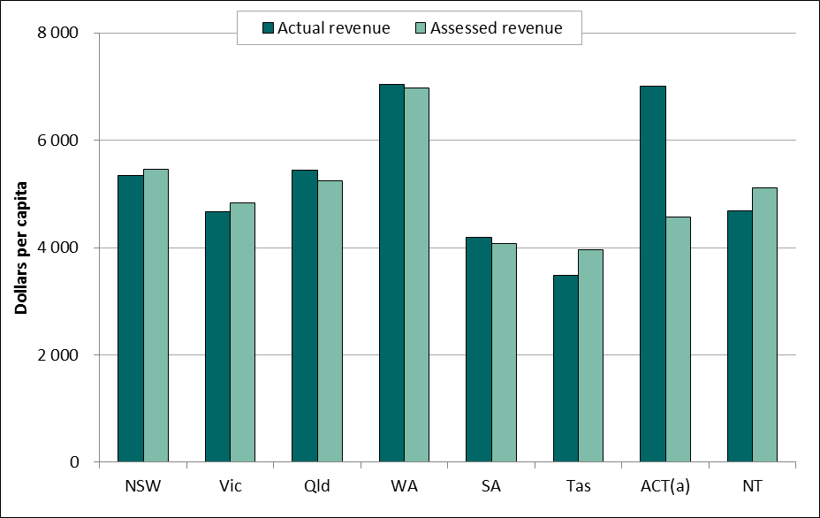

(a) The reason the ACT is different from other States is that the ACT does not have a separate local government sector. Its actual revenue includes $452 million ($1 112 per capita) in municipal rate revenue, revenue that is not included in other States’ actual revenues. The ACT’s municipal rate revenue is assessed EPC, which means it does not affect its GST share.

Source: Commission calculation.

##### Calculating assessed expenditure

* 1. The expenditure assessments start from a presumption that, if all things were equal, each State could provide the average level of service by spending the average amount per capita. However, State circumstances differ and this leads to differences in:
* the use of services, which can have an effect on the cost of providing services through:
* greater demand for services (some population groups may use services more often than others)
* greater cost per occasion of service (some population groups may cost more per occasion of service than others)
* the cost of inputs used in the provision of services, such as wages.
  1. For example:
* Hospital services are used more intensively (either through greater demand or greater cost per occasion of service) by some age groups and by Indigenous people. States are assessed to have a disability if the groups that make the most use of a service are a larger proportion of their population than they are of the national population. Conversely, they have an advantage (negative disability) if the size of the group is smaller than the national average.
* Cost of inputs covers interstate differences in wage related costs and inter‑regional differences in wage and non-wage related costs. In addition, some States face diseconomies of small scale, which result in higher per capita costs.
  1. However, higher costs arising from a State’s decision to provide a higher level of service, or lower efficiency level do not constitute a disability.
  2. Box A-2 describes how the Commission has presented disability assessments and assessed expenditure in the 2015 Review.

Box A-2 Presenting disability assessments and assessed expenditure

|  |
| --- |
| The Commission uses two presentations of disability assessments:   * factor based approach * State shares of disability measure.   ***Factor based approach.*** A disability factor for a State is calculated by relating its position to the average position. For example, for post-secondary education, a State’s relative disability factor is measured by comparing the proportion of its population aged 15 to 64 with the average proportion for the States as a whole. The disability factor can be written as the State ratio of the disability measure $θ,$ such as the population aged 15 to 64 over the State population divided by the equivalent all State ratio, as shown in equation (A). $$γ_{i}= \left({\frac{θ_{i}}{P_{i}}}/{\frac{θ_{s}}{P_{s}}}\right) (A)$$ To derive assessed expenditure for a State, the factor is multiplied by the average per capita expenditure and then multiplied by the State’s population, as shown in equation (B) $${AE}_{i}=P_{i} \frac{E_{s}}{P_{s}} γ_{i} (B)$$ Where:  AE assessed expenditure  i, s subscripts denote an individual State (i) or all States (s)  P population  E total State expenditure  γ assessed cost disability factor for an expenditure.  ***State shares of disability measure.*** The State shares of disability measure shows directly the State share of total expenditure by multiplying a State share of the disability measure by total expenditure. For example, to assess expenditure for post‑secondary education a State’s share of the total population aged 15 to 64 is multiplied by the total expenditure. The equivalence of this presentation and the factor based approach is shown below.  The terms in equation (A) and equation (B) can be rearranged as shown in equation (C). $${AE}_{i}=E_{s} \frac{P_{i}}{P_{s}} \frac{θ_{i} }{P_{i}}\frac{P_{s}}{θ_{s}} (C)$$ The State and total populations of equation (C) cancel out and assessed expenditure for a State can be expressed as total expenditure multiplied by a State’s share of the disability measure. $${AE}_{i}= E_{s}\frac{θ_{i}}{θ_{s}} (D)$$ ***Presentation of assessed expenditure.*** In the 2015 Review, the Commission decided to present the derivation of assessed expenditure using a combination of both presentations of disability assessment. Use disabilities, such as socio-demographic composition, are presented in the Commission’s calculations using the State shares of disability measure approach. Cost disabilities, such as wage costs, are presented using the factor based approach.  Equation (E) shows how assessed expenditures are derived in the Commission’s calculations. $${AE}_{I}= E_{s}\frac{θ_{ui}}{θ_{us}} γ_{ci} (E)$$ Where:  u, c use (u) and cost (c) disabilities. |

* 1. Figure A-2 shows total actual expenditure per capita and total assessed expenditure per capita, averaged over 2014-15 to 2016-17.

Figure A-2 Total actual and assessed expenditure per capita, average of 2014-15 to 2016‑17

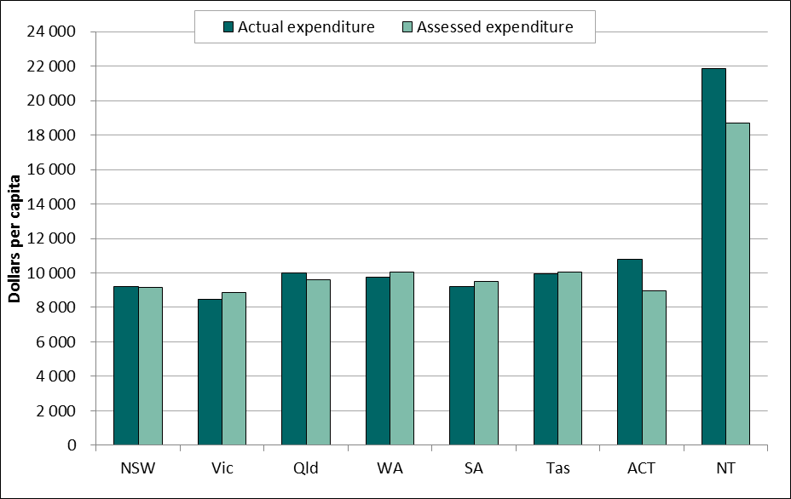

Source: Commission calculation.

## Attachment B – GST Redistribution

* 1. In the 2018 Update, the revenue and expenditure assessments redistributed $7 684 million in GST revenue (Table B-1).

Table B-1 Contribution of each revenue and expenditure category to differences in fiscal capacity, 2018 Update

|  |  |  |  |  |  |  |  |  |  |
| --- | --- | --- | --- | --- | --- | --- | --- | --- | --- |
|  | NSW | Vic | Qld | WA | SA | Tas | ACT | NT | Redist |
|  | $m | $m | $m | $m |  | $m | $m | $m | $m |
| Payroll tax | -536 | 423 | 478 | -993 | 466 | 200 | 7 | -46 | 1 575 |
| Land tax | -449 | -234 | 406 | -173 | 266 | 95 | 64 | 25 | 857 |
| Stamp duty | -2 097 | -229 | 418 | 715 | 790 | 248 | 45 | 109 | 2 326 |
| Insurance tax | -126 | 121 | 16 | 9 | -46 | 23 | 4 | -2 | 174 |
| Motor taxes | 275 | -10 | -76 | -161 | -31 | -28 | 24 | 8 | 307 |
| Mining revenue | 1 977 | 2 810 | -658 | -4 927 | 486 | 178 | 188 | -54 | 5 639 |
| Other revenue | 0 | 0 | 0 | 0 | 0 | 0 | 0 | 0 | 0 |
| **Total revenue** | **-956** | **2 882** | **583** | **-5 531** | **1 932** | **717** | **332** | **40** | **6 487** |
| School education | -281 | -1 226 | 715 | 420 | 13 | 96 | -80 | 342 | 1 586 |
| Post-secondary education | -22 | -51 | 19 | 25 | 0 | 1 | 6 | 22 | 73 |
| Health | -489 | -980 | 167 | 405 | 251 | 299 | -113 | 460 | 1 583 |
| Housing | -72 | -137 | 39 | 51 | 27 | 12 | -18 | 97 | 227 |
| Welfare | 5 | -607 | 286 | -9 | 48 | 86 | -61 | 253 | 677 |
| Services to communities | -391 | -379 | 121 | 203 | 42 | 12 | -24 | 417 | 795 |
| Justice | -243 | -670 | 258 | 251 | -17 | 19 | -47 | 448 | 976 |
| Roads | -219 | -260 | 130 | 237 | 71 | -12 | -46 | 99 | 537 |
| Transport | 307 | 557 | -369 | 23 | -157 | -198 | -70 | -95 | 888 |
| Services to industry | -119 | -88 | 12 | 151 | 16 | 10 | -15 | 34 | 223 |
| Other expenses | -653 | -571 | 123 | 239 | 84 | 188 | 310 | 280 | 1 224 |
| Depreciation | -252 | -559 | 104 | 327 | 92 | 23 | -36 | 300 | 847 |
| Investment | 333 | 1 254 | -426 | -485 | -332 | -159 | -20 | -165 | 1 587 |
| Net borrowing | 8 | -182 | 27 | 70 | 47 | 22 | -3 | 11 | 185 |
| **Total expense and investment (a)** | -2 088 | -3 900 | 1 206 | 1 908 | 187 | 400 | -216 | 2 503 | 6 204 |
| Commonwealth payments | 22 | 817 | -505 | 5 | 69 | -58 | 85 | -434 | 997 |
| **Total** | **-3 021** | **-201** | **1 284** | **-3 618** | **2 188** | **1 059** | **200** | **2 109** | **6 840** |

(a) This includes the impact of net borrowing.

Source: Commission calculation, 2018 Update.